NCERTPREP.COM

Exe -2 (A) Work Energy and Power

Question 1
Define work. When is work said to be done by a force?

Answer 1
Work is said to be done only when the force applied on a body makes the body move. It is a scalar quantity.

Question 2
How is the work done by a force measured when (i) force is in direction of displacement, (ii) force is at an angle to the direction of displacement?

Answer 2
(i) When force is in direction of displacement, then work done , W = FxS
(ii) When force is at an angle to the direction of displacement, then work done, W= F S cos

Question 3
A force F acts on a body and displaces it by a distance S in a direction at an angle with the direction of force. (a) Write the expression for the work done by the force. (b) What should be the angle between force and displacement so that the work done is (i) zero, (ii) maximum?

Answer 3
(a) When force is at an angle to the direction of displacement, then work done, W= F S cos
(b)
(i)For zero work done, the angle between force and displacement should be 90º as cos 90º=0
W =FScos90º= FSx0=0
(ii)For maximum work done, the angle between force and displacement should be 0º as cos0º=1
Hence, W=FScos 0º=FS

Question 4
A body is acted upon by a force. State two conditions when the work done is zero.

Answer 4
Two conditions when the work done is zero are:
(i)When there is no displacement (S=0) and,
(ii)When the displacement is normal to the direction of the force ( =90º).

Question 5
State the condition when the work done by a force is (i) positive, (ii) negative. Explain with the help of examples.

Answer 5
(i) If the displacement of the body is in the direction of force, then work done is positive.
Hence, W= F x S
For example: A coolie does work on the load when he raises it up against the force of gravity. The force exerted by coolie (=mg) and displacement, both are in upward direction.
(ii)If the displacement of the body is in the direction opposite to the force, then work done is negative.
Hence, W =- F x S
For example: When a body moves on a surface, the force of friction between the body and the surface is in direction opposite to the motion of the body and so the work done by the force of friction is negative.

Question 6
A body is moved in a direction opposite to the direction of force acting on it. State whether the work is done by the force or work is done against the force.

Answer 6
Work is done against the force.

Question 7
When a body moves in a circular path, how much work is done by the body? Give reason.
(Hint: The body is acted upon by the centripetal force).

Answer 7
When a body moves in a circular path, no work is done since the force on the body is directed towards the centre of circular path (the body is acted upon by the centripetal force), while the displacement at all instants is along the tangent to the circular path, i.e., normal to the direction of force.

Question 8
A satellite revolves around the earth in a circular orbit. What is the work done by the satellite? Give reason.

Answer 8
Work done by the force of gravity (which provides the centripetal force) is zero as the force of gravity acting on the satellite is normal to the displacement of the satellite.

Question 9
State whether work is done or not by writing yes or no, in the following cases?
(a) A man pushes a wall.
(b) A coolie stands with a box on his head for 15 min.
(c) A boy climbs up 20 stairs.

Answer 9
Work is done only in case of a boy climbing up a stair case.

Question 10
A coolie X Carrying a load on his head climbs up a slope and another coolie Y carrying the identical load on his head move the same distance on a frictionless horizontal platform. Who does more work? Explain the reason.

Answer 10
Energy is the capacity to do work and work done is equal to energy spent. Coolie X carrying a load up a slope will do more work as this works involve a change in potential energy, kinetic energy and loss of energy due to friction. Work done in carrying the load in horizontal frictionless surface does not involve change in potential energy and work done by the friction is also zero.

Question 11
The work done by a fielder when he takes a catch in a cricket match, is negative. Explain.

Answer 11
Force applied by the fielder on the ball is in opposite direction of displacement of ball. So, work done by the fielder on the ball is negative.

Question 12
Give an example when work done by the force of gravity acting on a body is zero even though the body gets displaced from its initial position.

Answer 12
When a coolie carries a load while moving on a ground, the displacement is in the horizontal direction while the force of gravity acts vertically downward. So the work done by the force of gravity is zero.

Question 13
What are the S.I. and C.G.S. units of work? How are they related? Establish the relationship.

Answer 13
S.I unit of work is Joule.
C.G.S unit of work is erg.
Relation between joule and erg :
1joule= 1N x 1m
But 1N =10⁵dyne
And 1m=100 cm= 10² cm
Hence, 1 joule= 10⁵dyne x 10²cm
=10⁷dyne x cm=10⁷erg
Thus, 1 Joule= 10⁷ erg

Question 14
State and define the S.I. unit of work.

Answer 14
S.I. unit of work is Joule.
1 joule of work is said to be done when a force of 1 newton displaces a body through a distance of 1 metre in its own direction.

Question 15
Express joule in terms of erg.

Answer 15
Relation between joule and erg :
1joule= 1N x 1m
But 1N =10⁵dyne
And 1m=100 cm= 10² cm
Hence, 1 joule= 10⁵dyne x 10²cm
=10⁷dyne x cm=10⁷erg
Thus, 1 Joule= 10⁷ erg

Question 16
A body of mass m falls down through a height h. Obtain an expression for the work done by the force of gravity.

Answer 16
Let a body of mass m fall down through a vertical height h either directly or through an inclined plane e.g. a hill, slope or staircase. The force of gravity on the body is F=mg acting vertically downwards and the displacement in the direction of force (i.e., vertical) is S=h. Therefore the work done by the force of gravity is
W= FS =mgh

Question 17
A boy of mass m climbs up a stairs of vertical height h.
(a) What is the work done by the boy against the force of gravity?
(b) What would have been the work done if he uses a lift in climbing the same vertical height?

Answer 17
Let a boy of mass m climb up through a vertical height h either through staircase of using a lift. The force of gravity on the boy is F=mg acting vertically downwards and the displacement in the direction opposite to force (i.e., vertical) is S=-h. Therefore the work done by the force of gravity on the boy is
W= FS =-mgh
or,the work W=mgh is done by the boy against the force of gravity.

Question 18
Define the term energy and state its S.I unit.

Answer 18
The energy of a body is its capacity to do work. Its S.I unit is Joule (J).

Question 19
What physical quantity does electron volt (eV) measure? How is it related to the S.I. unit of that quantity?

Answer 19
eV measures the energy of atomic particles.
1eV= 1.6 x 10⁻¹⁹J

Question 20
Complete the following sentence:
(a) 1 J = _____ calorie.
(b) 1 kWh = ______ J.

Answer 20
1 J = 0.24 calorie
1kWh= 3 cross times 10 to the power of 6 J

Question 21
Name the physical quantity which is measured in calorie. How is it related to the S.I unit of that quantity?

Answer 21
Calorie measures heat energy.
1calorie = 4.18 J

Question 22
Define a kilowatt hour. How is it related to joule?

Answer 22
1kWh is the energy spent (or work done) by a source of power 1kW in 1 h.
1kWh = 3.6 x 10⁶J

Question 23
Define the term power. State its S.I. unit.

Answer 23
The rate of doing work is called power. The S.I. unit of power is watt (W).

Question 24
State two factors on which power spent by a source depends. Explain your answer with examples.

Answer 24
Power spent by a source depends on two factors:
(i) The amount of work done by the source, and
(ii) The time taken by the source to do the said work.
Example: If a coolie A takes 1 minute to lift a load to the roof of a bus, while another coolie B takes 2 minutes to lift the same load to the roof of the same bus, the work done by both the coolies is the same, but the power spent by the coolie A is twice the power spent by the coolie B because the coolie A does work at a faster rate.

Question 25
Differentiate between work and power.

Answer 25
Work | Power
1. Work done by a force is equal to the product of force and the displacement in the direction of force. | 1. Power of a source is the rate of doing work by it.
2. Work done does not depend on time. | 2. Power spent depends on the time in which work is done.
3. S.I unit of work is joule (J). | 3. S.I unit of power is watt (W).

Question 26
Differentiate between energy and power.

Answer 26
Energy | Power
1. Energy of a body is its capacity to do work. | 1. Power of a source is the energy spent by it in 1s.
2. Energy spent does not depend on time. | 2. Power spent depends on the time in which energy is spent.
3. S.I unit of energy is joule (J). | 3. S.I unit of power is watt (W).

Question 27
State and define the S.I unit of power.

Answer 27
S.I unit of power is watt (W).
If 1 joule of work is done in 1 second, the power spent is said to be 1 watt.

Question 28
(a) Name the physical quantity measured in terms of horse power.
(b) How is horse power related to the S. I. unit of power?

Answer 28
(a)Power is measured in terms of horse power.
(b) 1 horse power =746 watt

Question 29
Differentiate between watt and watt hour.

Answer 29
Watt (W) is the unit of power, while watt hour (Wh) is the unit of work, since power x time = work.

Question 30
Name the quantity which is measured in
(a) kWh
(b) kW
(c) Wh
(d) eV

Answer 30
(a) Energy is measured in kWh
(b) Power is measure in kW
(c) Energy is measured in Wh
(d) Energy is meaused in eV
Concept insight: Energy has bigger units like kWh (kilowatt hour) and Wh (watt hour). Similarly bigger unit of power is kW (kilo watt).
The energy of atomic particles is very small, and hence, it is measured in eV (electron volt).

Question 31
Is it possible that no transfer of energy takes place even when a force is applied to a body?

Answer 31
Yes, there is no transfer of energy if the body is acted upon by the force normal to the displacement.
When the body is moving in a circular path, the force is normal to its displacement and the work done is zero.
Thus, there is no transfer of energy.

MCQs-2 (A) Work Energy and Power ICSE Class-10

Question 1
One horse power is equal to:
(a) 1000 W
(b) 500 W
(c) 764 W
(d) 746 W

Answer 1
(d) 746 W

Question 2
k Wh is the unit of:
(a) Power
(b) Force
(c) Energy
(d) None of these

Answer 2
(c) The unit kWh is the unit of energy.

Numericals-2 (A) ICSE Physics Solutions Selina

Question 1
A body, when acted upon by a force of 10 kgf, gets displaced by 0.5 m. Calculate the work done by the force, when the displacement is (i) in the direction of force, (ii) at an angle of 60º with the force, and (iii) normal to the force. (g= 10Nkg⁻¹)

Answer 1
Force acting on the body = 10 kgf = 10 x 10 N = 100 N
Displacement, S=0.5 m
Work done= force x displacement in the direction of force
(i)W =F x S
W = 100 x 0.5= 50 J
(ii)Work = force x displacement in the direction of force
W = F x S cos
W = 100 x 0.5 cos60º
W= 100 x0.5 x 0.5(cos60º=0.5)
W=25 J
(iii)Normal to the force:
Work = force x displacement in the direction of force
W = F x S cos
W = 100 x 0.5 cos90º
W= 100 x 0.5 x 0 =0 J(cos90º =0)

Question 2
A boy of mass 40kg climbs up the stairs and reaches the roof at a height 8m in 5 s. Calculate:
(i) The force of gravity acting on the boy,
(ii)The work done by him against gravity,
(iii)The power spent by boy.
(take g= 10ms⁻²)

Answer 2
Mass of boy=40 kg
Vertical height moved, h=8m
Time taken, t=5s.
(i) Force of gravity on the boy
F= mg =40 x 10 =400N
(ii)While climbing, the boy has to do work against the force of gravity.
Work done by the boy in climbing= Force x distance moved in the direction of force
Or, W = F x S= 400 x 8= 3200 J
(iii) Power spent = work done/time taken = 3200/5 = 640 W.

Question 3
A man spends 6.4 kJ energy in displacing a body by 64 m in the direction in which he applies force, in 2.5 s. Calculate: (i) the force applied and (ii) the power spent (in H.P) by the man.

Answer 3
Work done by man= 6.4kJ
Distance moved, S=64m
(i) Work done by the man= Force x distance moved in direction of force
Work, W= F x S
6.4 x 10³ =F x 64
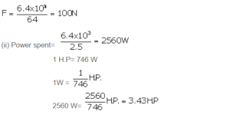

Question 4
A weight lifter lifted a load of 200 kgf to a height of 2.5 m in 5 s. Calculate: (i) the work done, and (ii) the power developed by him. Take g =10N/kg⁻¹.

Answer 4
Force= mg= 200 x 10=2000N
Distance, S= 2.5m
Time , t=5 s
(i)Work done, W= F S
W =2000 x 2.5m= 5000J
(ii)Power developed = work done/ time taken = 5000 J/ 5s = 1000 W.

Question 5
A machine raises a load of 750N through a height of 16m in 5 s. Calculate:
(i) the energy spent by the machine.
(ii) the power of the machine if it is 100% efficient.

Answer 5
(i)Energy spent by machine or work done= F S
Work, W =750 x 16= 12000J
(ii)Power spent= work done/time taken = 2400 W.

Question 6
An electric heater of power 3kW is used for 10h. How much energy does it consume?
Express your answer in (i) kWh (ii) joule.

Answer 6
Energy consumed = power x time
(i)Energy = 3 kW x 10 h=30 kWh
(ii)1 kilowatt hour (kWh)= 3.6 x 10⁶ J
30kWh = 30 x 3.6 x 10⁶ J
= 1.08 x 10⁸ J

Question 7
A water pump raises 50 litres of water through a height of 25m in 5 s. Calculate the power of the pump required.
(Take g= 10N kg⁻¹ and density of water =1000kg m⁻³).

Answer 7
Volume of water= 50 L=50 x 10⁻³ m³
Density of water= 1000 kgm⁻³
Mass of water= Volume of water x density of water
= 50 x10⁻³ x1000= 50kg
Work done in raising 50kg water to a height of 25m against the force of gravity is:
W = mg x h= mgh
Power P= work done/ time taken = 50*10*25 J/ 5s = 2500 W.

Question 8
A pump is used to lift 500kg of water from a depth of 80m in 10s. Calculate:
(a) The work done by the pump,
(b) The power at which the pump works, and
(c) The power rating of the pump if its efficiency is 40%. (Take g= 10m s⁻²).

Answer 8
Work done in raising a 500kg mass to a height of 80m against the force of gravity is:
(a)W = mg x h= mgh
W= 500 x 10 x80 =4 x10⁵J
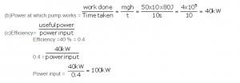

Question 9
An ox can apply a maximum force of 1000N. It is taking part in a cart race and is able to pull the cart at a constant speed of 30m/s⁻¹ while making its best effort. Calculate the power developed by the ox.

Answer 9
Given, force = 1000N, velocity=30m/s
Power, P= force x velocity
P = 1000 x 30 = 30,000W = 30kW

Question 10
The power of a motor is 40kW. At what speed can the motor raise a load of 20,000 N?

Answer 10
Power =40kW
Force= 20,000N
Power = force x velocity
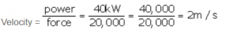

Question 11
Rajan exerts a force of 150 N in pulling a cart at a constant speed of 10 m s⁻¹. Calculate the power exerted.

Answer 11
Power exerted due to force is
P= Fv
P = 150 * 10 = 1500 W.

Question 12
A boy of weight 40 kgf climbs up the 15 steps, each 15 cm high in 10 s and a girl of weight 20 kgf does the same in 5 s. Compare : (i) the work done, and (ii) the power developed by them. Take g = 10 N kg⁻¹.

Answer 12
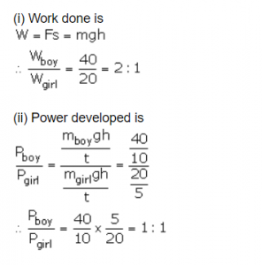

Question 13
It takes 20 s for a person A of mass 50 kg to climb up the stairs, while another person B of same mass does the same in 15 s. Compare the (i) work done and (ii) power developed by the persons A and B.

Answer 13
(i) The work done by persons A and B is independent of time. Hence both A and B will do the same amount of work. Hence,
work done by A/work done by B
1/1 = 1:1
(ii)Power developed by the person A and B is calculated as follows:A takes 20 s to climb the stairs while B takes 15 s, to do the same. Hence B does work at a much faster rate than A; more power is spent by B.
Power A/Power B = 15/20 = 3:4

Question 14
A boy of weight 40 kgf climbs up the 15 steps, each 15 cm high in 10 s and a girl of weight 20 kgf does the same in 5 s. Compare : (i) the work done, and (ii) the power developed by them. Take g = 10 N kg⁻¹.

Answer 14
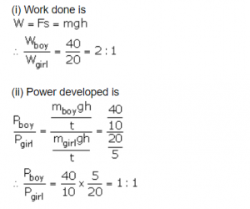

Question 15
A man raises a box of mass 50kg to a height of 2m in 20s, while another man raises the same box to the same height in 50s.
(a) Compare: (i) the work done, and (ii) the power developed by them.
(b) Calculated: (i) the work done, and (ii) the power developed by each man. Take g = 10N kg-1.

Answer 15
(a)
(i)Work done to raise the block of mass 50kg is same for both.
(ii) Power= Work done/time. As the time taken by the first man is less therefore power developed is more
(b)
(i)Work done = 50*10*2 = 1000 J
(ii) Power developed by first man=1000/20=50W
Power developed by second man=1000/50=20W

Question 16
A boy takes 3 minutes to lift a 20 litre water bucket from a 20 m deep well, while his father does it in 2 minutes. (a) Compare: (i) the work, and (ii) power developed by them. (b) How much work each does? Take density of water = 10³ kg m⁻³ and g = 9.8 N kg⁻¹.

Answer 16
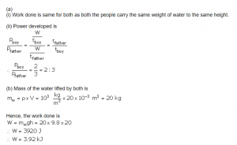

Exe- 2 (B) Work, Energy and Power Selina Physics Solution
Question 1
What are the two forms of mechanical energy?

Answer 1
Two forms of mechanical energy are:
(i) Kinetic energy
(ii) Potential energy

Question 2
Name the form of energy which a wound up watch spring possesses.

Answer 2
Elastic potential energy is possessed by wound up watch spring.

Question 3
Name the type of energy (kinetic energy K or potential energy U) possessed in the following cases:
(a) A moving cricket ball
(b) A compressed spring
(c) A moving bus
(d) A stretched wire
(e) An arrow shot out of a bow.
(f) A piece of stone placed on the roof.

Answer 3
(a)Kinetic energy (K)
(b)Potential energy (U)
(c)Kinetic energy (K)
(d)Potential energy (U)
(e)Kinetic energy (K)
(f)Potential energy (U)

Question 4
Define the term potential energy of a body. Name its two forms and given one example of each.

Answer 4
Potential energy: The energy possessed by a body by virtue of its specific position (or changed configuration) is called the potential energy.
Different forms of P.E. are as listed below:
(i) Gravitational potential energy: The potential energy possessed by a body due to its position relative to the centre of Earth is called its gravitational potential energy.
Example: A stone at a height has gravitational potential energy due to its raised height.
(ii) Elastic potential energy: The potential energy possessed by a body in the deformed state due to change in its configuration is called its elastic potential energy.
Example: A compressed spring has elastic potential energy due to its compressed state.

Question 5
Name the form of energy which a body may possess even when it is not in motion. Give an example to support your answer.

Answer 5
Potential energy is possessed by the body even when it is not in motion. For example: a stone at a height has the gravitational potential energy due to its raised position.

Question 6
What is meant by gravitational potential energy? Derive an expression for it for a body placed at a height above the ground.

Answer 6
Gravitational potential energy is the potential energy possessed by a body due to its position relative to the centre of earth.
For a body placed at a height above the ground, the gravitational potential energy is measured by the amount of work done in lifting it up to that height against the force of gravity.
Let a body of mass m be lifted from the ground to a vertical height h. The least upward force F required to lift the body (without acceleration) must be equal to the force of gravity (=mg) on the body acting vertically downwards. The work done W on the body in lifting it to a height h is
W= force of gravity (mg) x displacement (h)
=mgh
This work is stored in the body when it is at a height h in the form of its gravitational potential energy.
Gravitational potential energyU= mgh

Question 7
Write an expression for the potential energy of a body of mass m placed at a height h above the earth’s surface. State the assumptions made, if any.

Answer 7
The work done W on the body in lifting it to a height h is
W= force of gravity (mg) x displacement (h)
=mgh
This work is stored in the body when it is at a height h in the form of its gravitational potential energy.
Gravitational potential energy U= mgh

Question 8
What do you understand by the kinetic energy of a body?

Answer 8
A body in motion is said to possess the kinetic energy. The energy possessed by a body by virtue of its state of motion is called the kinetic energy.

Question 9
(a) A body of mass m is moving with a velocity v. Write the expression for its kinetic energy.
(b) Show that the quantity 2K/v² has the unit of mass, where K is the kinetic energy of the body.

Answer 9
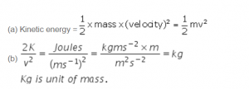
RELATED POSTS
Estimation ICSE Class-6th Concise Selina Maths Solutions
Apr 9, 2020
Integers ICSE Class-7th Concise Selina Maths Solutions
Apr 9, 2020

Question 10
State the work–energy theorem.

Answer 10
According to the work-energy theorem, the work done by a force on a moving body is equal to the increase in its kinetic energy.

Question 11
A body of mass m is moving with a uniform velocity u. A force is applied on the body due to which its velocity increases from u to v. How much work is being done by the force?

Answer 11
Body of mass m is moving with a uniform velocity u. A force is applied on the body due to which its velocity changes from u to v and produces an acceleration a in moving a distance S.Then,
Work done by the force= force x displacement
W = F x S———(i)
From relation : v² = u²+2 a S
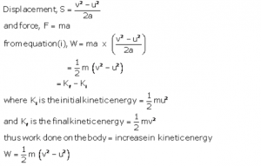

Question 12
A light mass and a heavy mass have equal momentum. Which will have more kinetic energy?
[Hint: kinetic energy K=p²/2m where p is the momentum]

Answer 12
Kinetic energy, K=p²/2m where p is the momentum.
Both the masses have same momentum p. The kinetic energy, K is inversely proportional to mass of the body.
Hence light mass body has more kinetic energy because smaller the mass, larger is the kinetic energy.

Question 13
Two bodies A and B of masses m and M (M≫ m) have same kinetic energy. Which body will have more momentum?

Answer 13
Kinetic energy is related to momentum and mass as √2mK
As the kinetic energy of both bodies are same, momentum is directly proportional to square root of mass.
Now, mass of body B is greater than that of body A.Hence, body B will have more momentum than body A.

Question 14
Name the three forms of kinetic energy and give one example of each.

Answer 14
The three forms of kinetic energy are:
(i) Translational kinetic energy- example: a freely falling body
(ii) Rotational kinetic energy-example: A spinning top.
(iii) Vibrational kinetic energy-example: atoms in a solid vibrating about their mean position.

Question 15
State two differences between the potential energy and the kinetic energy.

Answer 15
Potential energy (U) | Kinetic energy (K)
1. The energy possessed by a body by virtue of its specific position or changed configuration is called potential energy. | 1.The energy possessed by a body by virtue of its state of motion is called the kinetic energy.
2.Two forms of potential energy are gravitational potential energy and elastic potential energy. | 2. Forms of kinetic energy are translational, rotational and vibrational kinetic energy.
3.Example: A wound up watch spring has potential energy. | 3. For example: a moving car has kinetic energy.

Question 16
Complete the following sentences:
(a)The kinetic energy of a body is the energy by virtue of its _______.
(b)The potential energy of a body is the energy by virtue of its _______.

Answer 16
(a)Motion.
(b)Position.

Question 17
When an arrow is shot from a bow, it has kinetic energy in it. Explain briefly from where does it get its kinetic energy?

Answer 17
When the string of a bow is pulled, some work is done which is stored in the deformed state of the bow in the form of its elastic potential energy. On releasing the string to shoot an arrow, the potential energy of the bow changes into the kinetic energy of the arrow which makes it move.

Question 18
A ball is placed on a compressed spring. What form of energy does the spring possess? On releasing the spring, the ball flies away. Give a reason.

Answer 18
The compressed spring has elastic potential energy due to its compressed state. When it is released, the potential energy of the spring changes into kinetic energy which does work on the ball if placed on it and changes into kinetic energy of the ball due to which it flies away.

Question 19
A pebble is thrown up. It goes to a height and then comes back on the ground. State the different changes in form of energy during its motion.

Answer 19
When the pebble is thrown upwards, the kinetic energy in it is converted to potential energy.
At the top point in its motion, its kinetic energy is completely converted into potential energy.
While coming down, the potential energy is converted into kinetic energy and at the bottom the potential energy is completely converted to kinetic energy.

Question 20
In what way does the temperature of water at bottom of a waterfall differ from the temperature at the top? Explain the reason.

Answer 20
When water falls from a height, the potential energy stored in water at a height changes into the kinetic energy of water during the fall. On striking the ground, a part of the kinetic energy of water changes into the heat energy due to which the temperature of water rises.

Question 21
Name the form of energy in which potential energy can change.

Answer 21
Kinetic energy.

Question 22
Name the form of mechanical energy, which is put to use.

Answer 22
Kinetic energy.

Question 23
Name six different forms of energy?

Answer 23
The six different forms of energy are:
(a) Solar energy
(b) Heat energy
(c) Light energy
(d) Chemical or fuel energy
(e) Hydro energy
(f) Nuclear energy

Question 24
Energy can exist in several forms and may change from one form to another. For each of the following, state the energy changes that occur in:
(a) the unwinding of a watch spring
(b) a loaded truck when started and set in motion,
(c) a car going uphill,
(d) photosynthesis in green leaves,
(e) charging of a battery,
(f) respiration,
(g) burning of a match stick,
(h) explosion of crackers.

Answer 24
(a) Potential energy of wound up spring converts into kinetic energy.
(b) Chemical energy of petrol or diesel converts into mechanical energy (kinetic energy)
(c) Kinetic energy to potential energy
(d) Light energy changes into chemical energy
(e) Electrical energy changes into chemical energy
(f) Chemical energy changes into heat energy
(g) Chemical energy changes into heat and light energy
(h) Chemical energy changes into heat, light and sound energy

Question 25
State the energy changes in the following cases while in use:
(a)Loudspeaker
(b)A steam engine
(c)Microphone
(d)Washing machine
(e)A glowing electric bulb
(f)Burning coal
(g)A solar cell
(h)Bio-gas burner
(i)An electric cell in a circuit
(j)A petrol engine of a running car
(k)An electric iron
(l)A ceiling fan
(m)An electromagnet.

Answer 25
(a)Electrical energy into sound energy
(b)Heat energy into mechanical energy
(c)Sound energy into electrical energy
(d)Electrical energy to mechanical energy
(e)Electrical energy into light energy
(f)Chemical energy to heat energy
(g)Light energy into electrical energy
(h)Chemical energy into heat energy
(i)Chemical energy into electrical energy
(j)Chemical energy to mechanical energy
(k)Electrical energy into heat energy
(l)electrical energy into mechanical enegy
(m)Electrical energy into magnetic energy.

Question 26
Name the process used for producing electricity from the nuclear energy.

Answer 26
The process used to transfer nuclear energy to electrical energy is called nuclear fission.

Question 27
Is it practically possible to convert a form of energy completely into the other useful form? Explain your answer.

Answer 27
No. This is because, whenever there is conversion of energy from one form to another apart of the energy is dissipated in the form of heat which is lost to surroundings.

Question 28
What is degraded energy?

Answer 28
During the transformation of energy from one form to another desired form, some part of the energy gets converted to some undesirable form or a part of it is lost to the surroundings due to the friction or radiations which cannot be used for any productive purpose. This is called dissipation of energy, and this undesirable part of energy is called degraded energy.

Question 29
What do you mean by degradation of energy? Explain it by taking one example of your daily life.

Answer 29
During the transformation of energy from one form to another desired form, some part of energy is converted to some undesirable form or a part of it is lost to the surroundings due to the friction or radiations which cannot be used for any productive purpose. This is called dissipation of energy or degradation of energy.
Example:When a light bulb glows, a major part of the electrical energy utilised is converted to heat energy while some part is converted to useful light energy.

Question 30
Complete the following sentence:
The conversion of part of energy into an undesirable form is called……………. .

Answer 30
Conversion of part of energy into an undesirable form is called dissipation of energy/degradation of energy.

MCQs-2 (B) Work Energy and Power ICSE Physics Solutions
Question 1
A body at a height possesses:
(a) Kinetic energy
(b) Potential energy
(c) Solar energy
(d) Heat energy

Answer 1
(b) Potential energy

Question 2
In an electric cell while in use, the change in energy is from:
(a) Electrical to mechanical
(b) Electrical to chemical
(c) Chemical to mechanical
(d) Chemical to electrical

Answer 2
(d) Chemical to electrical

Numericals- 2 (B) Work, Energy and Power
Question 1
Two bodies of equal masses are placed at heights h and 2h. Find the ratio of their gravitational potential energies.

Answer 1
Height H₁= h
Height H₂= 2h
Mass of body 1= m
Mass of body 2= m
Gravitational potential energy of body 1 =mgH₁= mgh
Gravitational potential energy of Body 2=mgH₂= mg (2h)
Ratio of gravitational potential energies
= mgh/mg(2) = mgh/2mgh = 1/2 = 1:2

Question 2
Find the gravitational potential energy of 1kg mass kept at a height of 5m above the ground if g =10ms⁻².

Answer 2
Mass , m=1kg
Height, h=5m
Gravitational potential energy= mgh
=1 x 10 x5=50J

Question 3
A box of weight 150kgf has gravitational potential energy stored in it equal to 14700J. Find the height of the box above the ground.
(Take g= 9.8N/kg⁻¹).

Answer 3
Gravitational potential energy = 14700 J
Force of gravity = mg = 150 x 9.8N/kg = 1470N
Gravitational potential energy = mgh
14700 = 1470 x h
h = 10 m

Question 4
A body of mass 5 kg falls from a height of 10 m to 4 m. Calculate: (i) the loss in potential energy of the body, (ii) the total energy possessed by the body at any instant? (Take g = 10 ms⁻²).

Answer 4
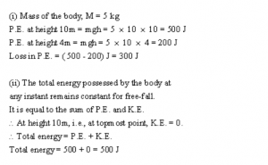

Question 5
Calculate the height through which a body of mass 0.5 kg should be lifted if the energy spent in doing so is 1.0 J. Take g = 10m/s^{–2}.

Answer 5
Mass = 0.5 kg
Energy = 1 J
Gravitational potential energy = mgh
1 = 0.5 x 10 x h
1 = 5h
Height, h = 0.2 m

Question 6
A boy weighing 25 kgf climbs up from the first floor at height 3 m above the ground to the third floor at height 9 m above the ground. What will be the increase in his gravitational potential energy?
(Take g=10 N kg⁻¹).

Answer 6
Force of gravity on boy=mg= 25 x 10 =250N
Increase in gravitational potential energy= Mg (h₂-h₁)
= 250 x (9-3)
=250 x6=1500 J

Question 7
A vessel containing 50 kg of water is placed at a height 15m above the ground. Assuming the gravitational potential energy at ground to be zero, what will be the gravitational potential energy of water in the vessel? (g = 10ms^{–2}).

Answer 7
Mass of water, m = 50 kg
Height, h = 15 m
Gravitational potential energy = mgh
=50 x 10 x 15
=7500 J

Question 8
A man of mass 50 kg climbs up a ladder of height 10m. Calculate: (i) the work done by the man, (ii) the increase in his potential energy.
(g= 9.8m s^{–2}).

Answer 8
Mass of man=50kg
Height of ladder, h₂=10m
(i)Work done by man =mgh₂
=50 x 9.8 x10= 4900J
(ii)increase in his potential energy:
Height,h₂= 10m
Reference point is ground, h₁=0m
Gravitational potential energy= Mg (h₂-h₁)
= 50 x 9.8 x (10-0)
= 50 x 9.8 x 10= 4900 J

Question 9
A block A, whose weight is 100N, is pulled up a slope of length 5m by means of a constant force F (=100N) as illustrated.
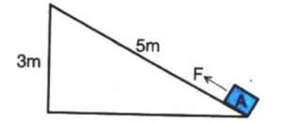
(a) What is the work done by the force F in moving the block A, 5m along the slope?
(b) What is the increase in potential energy of the block A?
(c) Account for the difference in the work done by the force and the increase in potential energy of the block.

Answer 9
(a) Work done by the force in moving the block 5m along the slope =Force x displacement in the direction of force =150 x 5=750 J
(b) The potential energy gained by the block U = mgh where h =3 m potential energy gained by the block
(c) =200 x 3=600 J
(d) The difference i.e., 150 J energy is used in doing work against friction between the block and the slope, which will appear as heat energy.

Question 10
Find the kinetic energy of a body of mass 1kg moving with a uniform velocity of 10m s⁻¹.

Answer 10
Mass, m =1kg
Velocity, v=10m/s
Kinetic energy= 1/2 mass * (velocity)²
1/2 * (10)² = 50 J.

Question 11
If the speed of a car is halved, how does its kinetic energy change?

Answer 11
If the speed is halved (keeping the mass same), the kinetic energy decreases, it becomes one-fourth (since kinetic energy is proportional to the square of velocity).

Question 12
Calculate the decrease in the kinetic energy of a moving body if its velocity reduces to half of the initial velocity.

Answer 12
Kinetic energy is directly proportional to the square of velocity.
Velocity is reduced to half its original value. So, we get
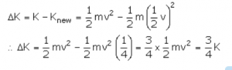

Question 13
Two bodies of equal masses are moving with uniform velocities v and 2v. Find the ratio of their kinetic energies.

Answer 13
Given, velocity of first body v₁=v
And velocity of second body, v₂ =2v
Since masses are same, kinetic energy is directly proportional to the square of the velocity ()
Hence, ratio of their kinetic energies is: 1:4

Question 14
A car is running at a speed of 15 km h⁻¹ while another similar car is moving at a speed of 45 km h⁻¹. Find the ratio of their kinetic energies.

Answer 14
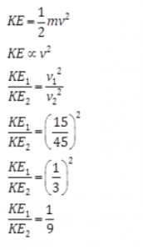

Question 15
A ball of mass 0.5 kg slows down from a speed of 5m/s⁻¹ to that of 3m/s⁻¹. Calculate the change in kinetic energy of the ball.

Answer 15
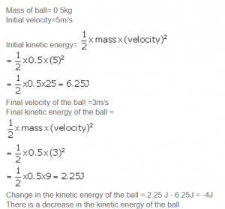

Question 16
A canon ball of mass 500 g is fired with a speed of 15m/s⁻¹. Find: (i) its kinetic energy and (ii) its momentum.

Answer 16
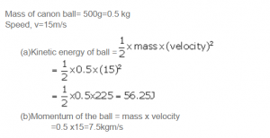

Question 17
A body of mass 10 kg is moving with a velocity 20m s⁻¹. If the mass of the body is doubled and its velocity is halved, find: (i) the initial kinetic energy, and (ii) the final kinetic energy.

Answer 17
Let initial Mass, m₁= 10kg and velocity, v₁ =20 m/s
Final mass, m₂=2 x10=20 kg and velocity, v₂=20/2= 10m/s
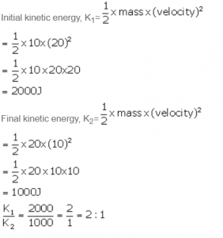

Question 18
A truck weighing 1000 kgf changes its speed from 36 km/h⁻¹ to 72 km/h⁻¹ in 2 minutes. Calculate: (i) the work done by the engine and (ii) its power.(g =10 m/s^{–2})

Answer 18
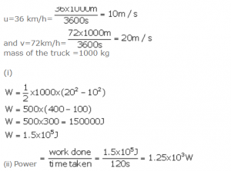

Question 19
A body of mass 60 kg has the momentum 3000 kgm/s⁻¹. Calculate: (i) the kinetic energy and (ii) the speed of the body.

Answer 19
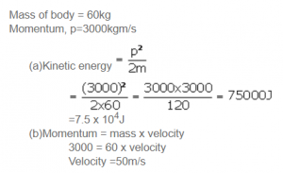

Question 20
How much work is needed to be done on a ball of mass 50 g to give it a momentum of 5 kg m s⁻¹ ?

Answer 20
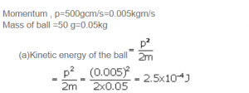

Question 21
How much energy is gained by a box of mass 20 kg when a man
(a) carrying the box waits for 5 minutes for a bus?
(b) runs carrying the box with a speed of 3 m/s⁻¹ to catch the bus?
(c) raises the box by 0.5 m in order to place it inside the bus? (g=10 m/s^{–2})

Answer 21
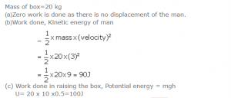

Question 22
A bullet of mass 50g is moving with a velocity of 500m/s⁻¹. It penetrates 10 cm into a still target and comes to rest. Calculate: (a) the kinetic energy possessed by the bullet, and (b) the average retarding force offered by the target.

Answer 22
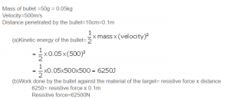

Question 23
A spring is kept compressed by a small trolley of mass 0.5 kg lying on a smooth horizontal surface as shown. When the trolley is released, it is found to move at a speed of v = 2 m/s⁻¹. What potential energy did the spring possess when compressed?
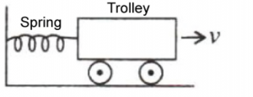

Answer 23
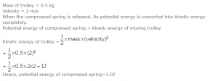

Exe -2(C) Work, Energy and Power ICSE Physics
Question 1
State the Principle of conservation of energy.

Answer 1
According to the law of conservation of energy, energy can neither be created nor can it be destroyed. It only changes from one form to another.

Question 2
What do you understand by the conservation of mechanical energy? State the condition under which the mechanical energy is conserved.

Answer 2
According to the law of conservation of mechanical energy, whenever there is an interchange between the potential energy and kinetic energy, the total mechanical energy (i.e., the sum of kinetic energy K and potential energy U) remains constant i.e., K + U = constant when there are no frictional forces.
Mechanical energy is conserved only when there are no frictional forces for a given system (i.e. between body and air). Thus, conservation of mechanical energy is strictly valid only in vacuum, where friction due to air is absent.

Question 3
Name two examples in which the mechanical energy of a system remains constant.

Answer 3
Motion of a simple pendulum and motion of a freely falling body.

Question 4
A body is thrown vertically upwards. Its velocity keeps on decreasing. What happens to its kinetic energy as its velocity becomes zero?

Answer 4
Kinetic energy of the body changes to potential energy when it is thrown vertically upwards and its velocity becomes zero.

Question 5
A body falls freely under gravity from rest. Name the kind of energy it will possess
(a)At the point from where it falls.
(b)While falling
(c)On reaching the ground.

Answer 5
(a)Potential energy
(b)Potential energy and kinetic energy
(c)Kinetic energy

Question 6
Show that the sum of kinetic energy and potential energy (i.e., total mechanical energy) is always conserved in the case of a freely falling body under gravity (with air resistance neglected) from a height h by finding it when (i) the body is at the top, (ii) the body has fallen a distance x, (iii) the body has reached the ground.

Answer 6
Let a body of mass m be falling freely under gravity from a height h above the ground (i.e., from position A). Let us now calculate the sum of kinetic energy K and potential energy U at various positions, say at A (at height h above the ground), at B (when it has fallen through a distance x) and at C (on the ground).

Question 7
A pendulum is oscillating on either side of its rest position. Explain the energy changes that take place in the oscillating pendulum. How does the mechanical energy remain constant in it? Draw necessary diagram.

Answer 7
When the bob swings from A to B, the kinetic energy decreases and the potential energy becomes maximum at B where it is momentarily at rest.
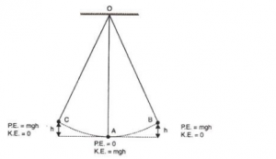
From B to A, the potential energy again changes into the kinetic energy and the process gets repeated again and again.
Thus while swinging, the bob has only the potential energy at the extreme position B or C and only the kinetic energy at the resting position A. At an intermediate position (between A and B or between A and C), the bob has both the kinetic energy and potential energy, and the sum of both the energies (i.e., the total mechanical energy) remains constant throughout the swing.

Question 8
A pendulum with bob of mass m is oscillating on either side from its resting position A between the extremes B and C at a vertical height h above A. What is the kinetic energy K and potential energy U when the pendulum is at positions (i) A, (ii) B and (iii) C?

Answer 8
(a)At position A, pendulum has maximum kinetic energy and its potential energy is zero at its resting position. Hence, K=mgh and U= 0.
(b)At B, kinetic energy decreases and potential energy increases. Hence, K= 0 and U=mgh
(c)At C also, kinetic energy K= 0 and potential energy U=mgh.

Question 9
Name the type of energy possessed by the bob of a simple pendulum when it is at (a) the extreme position, (b) the mean position, and (c) between the mean and extreme positions.

Answer 9
(a)Extreme position: Potential energy
(b)Mean position: Kinetic energy
(c)Between mean and extreme: Both kinetic energy and potential energy

MCQs- 2 (C) Work Energy and Power ICSE Selina Solutions Chapter-2
Question 1
A ball of mass m is thrown vertically up with an initial velocity so as to reach a height h. The correct statement is:
(a) Potential energy of the ball at the ground is mgh.
(b) Kinetic energy to the ball at the ground is zero.
(c) Kinetic energy of the ball at the highest point is mgh.
(d) Potential energy of the ball at the highest point is mgh.

Answer 1
(d) Potential energy of the ball at the highest point is mgh.

Question 2
A pendulum is oscillating on either side of its rest position. The correct statement is :
(a) It has only the kinetic energy at its each position.
(b) It has the maximum kinetic energy at its extreme position.
(c) It has the maximum potential energy at its mean position.
(d) The sum of its kinetic and potential energy remains constant throughout the motion.

Answer 2
(d) The sum of its kinetic and potential energy remains constant throughout the motion.

Numericals-2 (C) Physics Selina Solution Work, Energy and Power
Question 1
A ball of mass 0.20 kg is thrown vertically upwards with an initial velocity of 20m/s⁻¹. Calculate the maximum potential energy it gains as it goes up.

Answer 1
Potential energy at the maximum height= initial kinetic energy 1/2 mv²
1/2* 0.20* 0*20*20 = 40 J

Question 2
A stone of mass 500g is thrown vertically upwards with a velocity of 15m/s⁻¹. Calculate: (a) the potential energy at the greatest height, (b) the kinetic energy on reaching the ground (c) the total energy at its half way point.

Answer 2
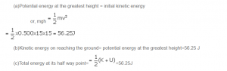

Question 3
A metal ball of mass 2kg is allowed to fall freely from rest from a height of 5m above the ground.
(a) Taking g = 10m/s², calculate:
(i) the potential energy possessed by the ball when it is initially at rest.
(ii) the kinetic energy of the ball just before it hits the ground?
(b)What happens to the mechanical energy after the ball hits the ground and comes to rest?

Answer 3
(a)
(i) Potential energy of the ball =mgh
=2 x 10 x 5=100J
(ii)Kinetic energy of the ball just before hitting the ground = Initial potential energy= mgh=2x10x5=100J
(b)Mechanical energy converts into heat and sound energy.

Question 4
The diagram given below shows a ski jump.A skier weighing 60kgf stands at A at the top of ski jump. He moves from A and takes off for his jump at B.
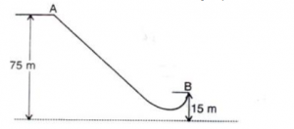

(a)Calculate the change in the gravitational potential energy of the skier between A and B.
(b)If 75% of the energy in part (a) becomes the kinetic energy at B, calculate the speed at
which the skier arrives at B.
(Take g = 10 m s⁻²).

Answer 4
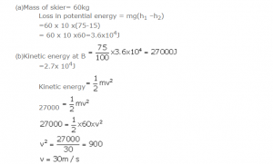

Question 5
A hydro electric power station takes its water from a lake whose water level is 50m above the turbine. Assuming an overall efficiency of 40%, calculate the mass of water which must flow through the turbine each second to produce power output of 1MW.
(g=10 m s⁻²).

Answer 5
Potential energy = mgh
Efficiency = 40 %
Useful work done = 40 % of potential energy
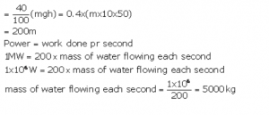

Question 6
The bob of a simple pendulum is imparted a velocity of 5m s⁻¹ when it is at its mean position. To what maximum vertical height will it rise on reaching at its extreme position if 60% of its energy is lost in overcoming the friction of air?
(Take g = 10 m s⁻²).

Answer 6
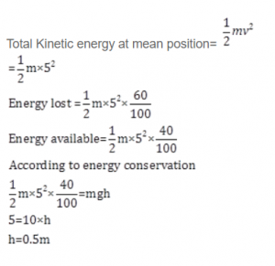
Return to Concise Selina ICSE Physics Class-10
Thanks

