NCERTPREP.COM

Exercise – 4(A) Refraction of light at Plane Surfaces ICSE Class-10

Question 1
What do you understand by refraction of light?

Answer 1
The change in the direction of the path of light, when it passes from one transparent medium to another transparent medium, is called refraction of light.

Question 2
Draw diagrams to show the refraction of light from (i) air to glass, (ii) glass to air. In each diagram, label the incident ray, refracted ray, the angle of incidence (i) and the angle of refraction (r).

Answer 2
Diagram showing the refraction of light from Air to glass
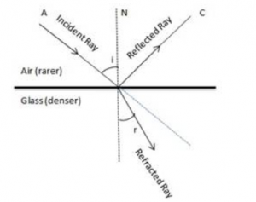
Diagram showing the refraction of light from Glass to Air
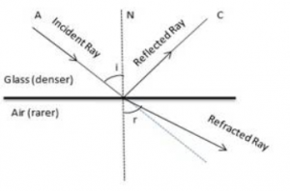

Question 3
A ray of light is incident normally on a plane glass slab. What will be (i) the angle of refraction and (ii) the angle of deviation for the ray?

Answer 3
The ray of light which is incident normally on a plane glass slab passes undeviated. That is such a ray suffers no bending at the surface because here the angle of incidence is . Thus if angle of incidence , then the angle of refraction . And the angle of deviation of the ray will also be .

Question 4
An obliquely incident light ray bends at the surface due to change in speed, when passing from one medium to other. The ray does not bend when it is incident normally. Will the ray have different speed in the other medium?

Answer 4
Yes it will. When the medium changes, the speed of light changes.

Question 5
What is the cause of refraction of light when it passes from one medium to another?

Answer 5
The refraction of light (or change in the direction of path of light in other medium) occurs because light travels with different speeds in different media. When a ray of light passes from one medium to another, its direction (except for ) changes because of change in its speed.

Question 6
A light ray suffers reflection and refraction at the boundary in passing from air to water. Draw a neat labelled diagram to show it.

Answer 6
Air is a rarer medium while water is denser than air with refractive index of 1.33. Therefore when light ray will travel from air to water it will bend towards the normal.
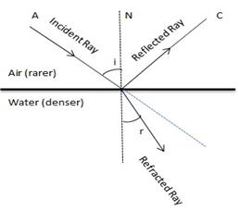

Question 7
A ray of light passes from medium 1 to medium 2. Which of the following quantities of the refracted ray will differ from that of incident ray: speed, intensity, frequency, wavelength?

Answer 7
Speed, intensity and wavelength

Question 8
State the Snell’s laws of refraction of light.

Answer 8
The Snell’s laws of refraction are:
1.The incident ray, the refracted ray and the normal at the point of incidence, all lie in the same plane.
2.The ratio of the sine of the angle of incidence to the sine of the angle of refraction is constant for the pair of the given media.
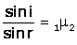
where is known as the refractive index of the second medium with respect to the first medium.

Question 9
Define the term refractive index of a medium. Can it be less than 1?

Answer 9
The refractive index of second medium with respect to first medium is defined as the ratio of the sine of angle of incidence in the first medium to the sine of the angle of refraction in the second medium.
Refractive index of a medium is always greater than 1 (it cannot be less than 1) because the speed of light in any medium is always less than that in vacuum

Question 10
(a) Compare the speeds of light of wavelength 4000 (i.e. violet light) and 8000 (i.e. red light) in vacuum.
(b) How is the refractive index of a medium related to the speed of light in it and in vacuum or air?

Answer 10
(a) Speed of light depends on medium not on wavelength hence speed will be same for both.
(b) Denser medium has a higher refractive index and therefore the speed of light in such medium is lower in comparison to the speed of light in a medium which has a lower refractive index.

Question 11
A light ray passes from water to (i) air, and (ii) glass. In each case, state how does the speed of light change.

Answer 11
Refractive index of water,
Refractive index of air,
Refractive index of glass,
This implies that
The speed of light decreases when it enters from a rarer medium to denser medium and increases when it enters from a denser medium to rarer medium.
Therefore, the speed of light increases when light ray passes from water to air and the speed of light decreases when light ray passes from water to glass.

Question 12
A light ray in passing from water to a medium (a) speeds up (b) slows down. In each case, (i) give one example of the medium, (ii) State whether the refractive index of medium is equal to, less than or greater than the refractive index of water.

Answer 12
When the speed increases it means that the refractive index of the medium is less than that of water.
When the speed decreases it means that the refractive index of the medium is greater than that of water.

Question 13
What do you understand by the statement ‘the refractive index of the glass is 1.5 for white light’?

Answer 13
The refractive index of glass is 1.5 for white light means white light travels in air 1.5 times faster than in glass.

Question 14
A monochromatic ray of light passes form air to glass. The wavelength of light in air is , the speed of light in air is c and in glass is v. If the refractive index of glass is 1.5, write down (a) the relationship between c and v, (b) the wavelength of light in glass.

Answer 14
(a) The relation between speed of light in air c and in glass v is given by
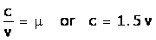
(b) The wavelength of light in glass ( )
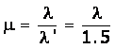

Question 15
In an experiment of finding the refractive index of glass, if blue light is replaced by the red light, how will the refractive index of glass change? Give reason in support of your answer.

Answer 15
In glass, the speed of blue light is less than that of the red light. Now, the refractive index is μ = c/v. Hence, the refractive index of glass for red light will decrease as compared to that for blue light.

Question 16
(a) For which colour of white light, is the refractive index of a transparent medium (i) the least (ii) the most?
(b) Which colour of light travels fastest in any medium except air?

Answer 16
(a) (i) The least for red colour and (ii) the most for violet colour.
(b) Red colour travels the fastest as its wavelength is the highest.

Question 17
Name two factors on which the refractive index of a medium depends? State how does it depends on the factor state by you.

Answer 17
The two factors on which the refractive index of a medium depends are:
1) Nature of a medium i.e. its optical density (e.g. =1.5, =1.33) – Smaller the speed of light in a medium relative to air, higher is the refractive index of that medium.
2) Physical condition such as temperature – with increase in temperature, the speed of light in medium increases, so the refractive index of medium decreases.

Question 18
How does the refractive index of a medium depend on the wavelength of light used?

Answer 18
Refractive index of a medium decreases with increase in wavelength of light.
Refractive index of a medium for violet light (least wavelength) is greater than that for red light (greatest wavelength).

Question 19
How does the refractive index of a medium depend on its temperature?

Answer 19
Refractive index of a medium decreases with the increase in temperature.
With increase in temperature, the speed of light in that medium increases; thus, the refractive index (= velocity of light in vacuum/velocity of light in medium) decreases.

Question 20
Light of a single colour is passed through a liquid having a piece of glass suspended in it. On changing the temperature of liquid, at a particular temperature, the glass piece is not seen.
(i) When is the glass piece not seen?
(ii) Why is the light of a single colour used?

Answer 20
(i) The glass piece is not seen when the refractive index of liquid becomes equal to the refractive index of glass.
(ii) Light of a single colour is used because the refractive index of a medium (glass or liquid) is different for the light of different colours.

Question 21
In the figure below 4.18 , a ray of light A incident from air suffers partial reflection and refraction at the boundary of water.
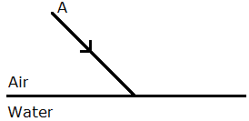
Complete the diagram showing (i) the reflected ray B and (ii) the refracted ray C.
How are the angles of incidence i and refraction r related?

Answer 21
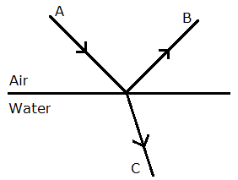
- The angles of incidence and refraction are related to each other by Snell’s law relation sin i/sin r = μ_{w}.

Question 22
The diagram alongside shows the refraction of a ray of light from air to liquid.
(a) Write the values of (i) angle of incidence, and (ii) angle of refraction.
(b) Use Snell’s law to find the refractive index of liquid with respect to air.
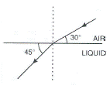

Answer 22
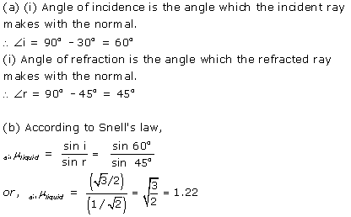

Question 23
The refractive index of water with respect to air is and of glass with respect to air is .Express the refractive index of glass with respect to water.

Answer 23
Refractive index of glass with respect to water is given by
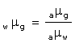

Question 24
What is lateral displacement? Draw a ray diagram showing the lateral displacement of a ray of light when it passes through a parallel sided glass slab.

Answer 24
The perpendicular distance between the path of emergent ray and the direction of the incident ray is called the lateral displacement.
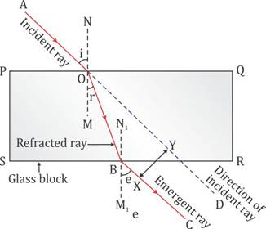
In the figure above, XY is the perpendicular distance or the lateral displacement.

Question 25
A ray of light strikes the surface at a rectangular glass slab such that the angle of incidence is (i) 0º, (ii) 45º. In each case, draw diagram to show the path taken by the ray as it passes through the glass slab and emerges from it.

Answer 25
Case (i) when angle of incidence is 0º.
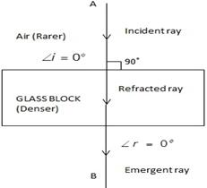
Case (ii) When angle of incidence is 45º.
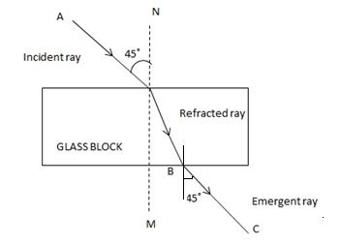

Question 26
In the adjacent diagram, AO is a ray of light incident on a rectangular glass slab.
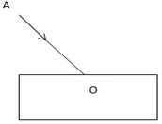
(a) Complete the path of the ray till it emerges out of the slab.
(b) In the ray diagram, mark the angle of incidence (i) and the angle of refraction (r) at the first
interface. How is the refractive index of glass related to angles i and r ?
(c) Mark angle of emergence by the letter e. How are the angles i and e related?
(d) Which two rays are parallel to each other? Name them.
(e) Indicate in the diagram the lateral displacement between the emergent ray and the incident ray.

Answer 26
(a)The complete path of incident ray in glass block is drawn in figure below.
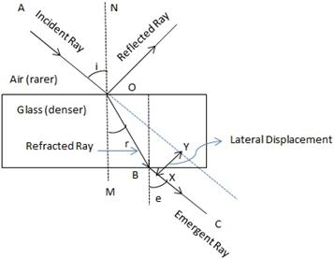
(b)Angle of incidence (i) and angle of refraction (r) are marked in part (a).
Refractive index ( ) of glass is related to the angles as
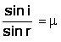
(c)Angle of emergence (e) is marked in part (a)
The two angles are related to each other by the relation
(d)Incident ray and emergent ray are parallel to each other.
(e)Lateral displacement is indicated in the figure by XY.

Question 27
A ray of green light enters a liquid from air, as shown in the figure. The angle 1 is 45º and angle 2 is 30º.
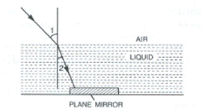
(a) Find the refractive index of liquid.
(b) Show in the diagram the path of the ray after it strikes the mirror and re-enters in air. Mark in the diagram the angles wherever necessary.
(c) Redraw the diagram if plane mirror becomes normal to the refracted ray inside the liquid. State the principal used.

Answer 27
(a) Refractive index of the liquid =
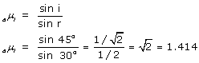
(b)
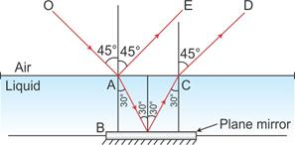
(c)
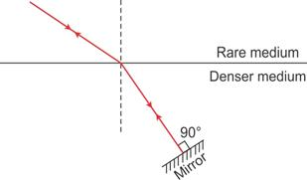
Here the ‘Principle of Reversibility’ is used.

Question 28
When an illuminated object is held in front of a thick plane glass mirror, several images are seen, out of which the second image is the brightest. Give reason.

Answer 28
When a ray of light from lighted candle fall on the surface of a thick plane glass mirror, a small part of light (nearly 4%) is reflected forming first image which is faint virtual image, while a large part of light (nearly 96%) is refracted inside the glass. This ray is now strongly reflected back by the silvered surface inside the glass. This ray is then partially refracted in air and this refracted ray forms another virtual image. This image is the brightest image because it is due to the light suffering a strong reflection at the silver surface.

Question 29
Fill in the blanks to complete the following sentences:
(a) When light travels from a rarer to a denser medium, its speed ………………….
(b) When light travels from a denser to a rarer medium, its speed ………………….
(c) The refractive index of glass with respect to air is 3/2. The refractive index of air with respect to glass will be ………………….

Answer 29
(a) When light travels from a rarer to a denser medium, its speed decreases
(b) When light travels from a denser to a rarer medium, its speed increases
(c) The refractive index of glass with respect to air is 3/2. The refractive index of air with respect to glass will be 2/3

Refraction of light at Plane Surface “Selina Solution”
RELATED POSTS
Estimation ICSE Class-6th Concise Selina Maths Solutions
Apr 9, 2020
Integers ICSE Class-7th Concise Selina Maths Solutions
Apr 9, 2020

Multiple Choice Type – 4(A)

Question 1
When a ray of light from air enters a denser medium, it:
(a) Bends away from the normal
(b) Bends towards the normal
(c) Goes undeviated
(d) Is reflected back

Answer 1
The ray of light bends towards the normal.
Reason: As the speed of light decreases in the denser medium, it bends towards the normal.

Question 2
A light ray does not bend at the boundary in passing from one medium to the other medium if the angle of incidence is:
(a) 0°
(b) 45°
(c) 60°
(d) 90°

Answer 2
(a) 0°
Reason: A ray of light which is incident normally (i.e. at angle of incidence = 0°) on the surface separating the two media, passes undeviated.

Question 3
The highest refractive index is of:
(a) Glass
(b) Water
(c) Diamond
(d) Ruby

Answer 3
Diamond
Reason: As the speed of light in diamond is the least, diamond has the highest refractive index.

Numericals 4(A) Selina Solution – Refraction of light at Plane Surface
Question 1
The speed of light in air is 3 x 10⁸ m s⁻¹. Calculate the speed of light in glass. The refractive index of glass is 1.5.

Answer 1
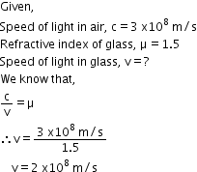

Question 2
The speed of light in diamond is 125,000 km s⁻¹. What is the refractive index? (speed of light in air = 3 x 10⁸ m s⁻¹).

Answer 2
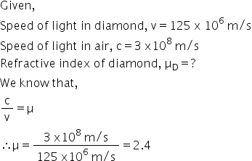

Question 3
The refractive index of water with respect to air is 4/3. What is the refractive index of air with respect to water?

Answer 3
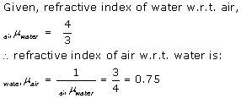

Question 4
A ray of light of wavelength 5400 suffers refraction from air to glass. Taking = =3/2, find the wavelength of light in glass.

Answer 4
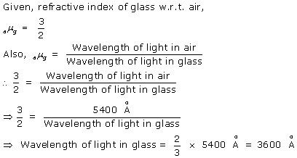

Selina Solution “Refraction of light at plane surface”
Exercise 4 (B)

Question 1
What is a prism?
With the help of a diagram of a prism, indicate its refracting surfaces, refracting edges and base.

Answer 1
A prism is a transparent refracting medium bounded by five plane surfaces inclined at some angle.
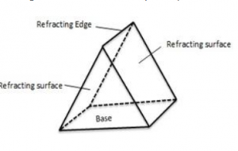

Question 2
The diagrams (a) and (b) in Fig. below show the refraction of a monochromatic ray of light through a parallel sided glass block and prism, respectively.
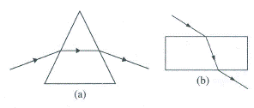
(a) In each diagram, label the incident, refracted, emergent rays and the
(b) In what way the direction of emergent ray in the two cases differ with respect to the incident ray? Explain your answer.

Answer 2
(a)
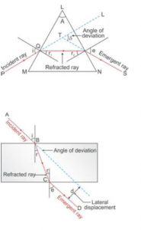
(b) For the prism, the emergent ray is not parallel to the incident ray but for the glass block it is parallel. This is because, in a prism, refraction takes place at two inclined surfaces while in a glass block refraction takes place at two parallel surfaces.

Question 3
Define the term angle of deviation.

Answer 3
The angle between the direction of incident ray and the emergent ray, is called the angle of deviation.

Question 4
Complete the following sentence:
Angle of deviation is the angle which the ________ ray makes with the direction of ________ ray.

Answer 4
Angle of deviation is the angle which the emergent ray makes with the direction of incident ray.

Question 5
What do you understand by the deviation produced by a prism? Why is it caused? State three factors on which angle of deviation depends.

Answer 5
In a prism the ray of light suffers refraction at two faces. The prism produces a deviation at the first surface and another deviation at the second surface. Thus a prism produces a deviation in the path of light.
The value of the angle of deviation (or the deviation produced by a prism) depends on the following four factors:
(a)the angle of incidence (i),
(b)the material of prism(i.e., on refractive index ),
(c)the angle of prism (A),
(d)The colour or wavelength ( ) of light used.

Question 6
(a) How does the angle of deviation produced by a prism change with increase in the angle of incidence. Draw a curve showing the variation in the angle of deviation with the angle of incidence at a prism surface.
(b) Using the curve in part (a) above, how do you infer that for given prism, the angle of minimum deviation δ_{min} is unique for the given light.

Answer 6
(a) As the angle of incidence increases, the angle of deviation decreases first and reaches to a minimum value ( ) for a certain angle of incidence. By further increasing the angle of incidence, the angle of deviation is found to increase.
Variation of angle of deviation () with angle of incidence(i):
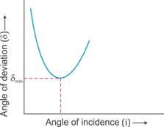
(b) For a given prism and given colour of light, angle of minimum deviation is unique since only one horizontal line can be drawn parallel to the i-axis at the lowest point of i-δ curve.

Question 7
State whether the following statement is ‘true’ or ‘false’.
The deviation produced by a prism is independent of the angle of incidence and is same for all the colours of light.

Answer 7
False.
With the increase in the angle of incidence, the deviation produced by a prism first decreases and then increases.
A given prism deviates the violet light most and the red light least.

Question 8
How does the deviation produced by a prism depend on (i) the refraction index of its material, and
(ii) the wavelength of incident light

Answer 8
(i) For a given angle of incidence, the prism with a higher refractive index produces a greater deviation than a prism with a lower refractive index.
(ii) The refractive index of a medium is different for light of different colours. It increases with decrease in wavelength. Thus, the refractive index of the material of prism is maximum for violet and least for red light. Hence, the prism deviates violet light the most and red light the least, i.e., δ_{violet} > δ_{red}.

Question 9
How does the angle of minimum deviation produced by a prism change with increase in (i) the wavelength of incident light and (ii) the refracting angle of the prism?

Answer 9
Changes in the angle of deviation as we increase
(i) The wavelength of incident light
As we increase the wavelength, angle of deviation decreases.
(ii) The refracting angle of the prism
The angle of deviation increases with the increase in the angle of prism.

Question 10
Write a relation for the angle of deviation() for a ray of light passing through an equilateral prism in terms of angle of incident (i), angle of emergence (e), angle of prism (A).

Answer 10
The relation between the angle of incident (i), angle of emergence (e), angle of prism (A) and angle of deviation ( ) for a ray of light passing through an equilateral prism is

Question 11
A ray of light incident at an angle of incidence i₁ passes through an equilateral glass prism such that the refracted ray inside the prism is parallel to its base and emerges at an angle of emergence i₂.
How is the angle of emergence ‘i₂‘ related to the angle of incidence ‘i₁‘.
What can you say about the angle of deviation in such a situation?

Answer 11
(i) i₂ = i₁
(ii) Angle of deviation is minimum
Explanation: In minimum deviation position, the refracted ray inside the prism travels parallel to it if the prism is equilateral and the angle of incidence is equal to the angle of emergence.

Question 12
Draw a ray diagram to show the refraction of a monochromatic ray through a prism when it suffers minimum deviation. How is the angle of emergence related to the angle of incidence in this position.

Answer 12
In case of an equilateral prism, when the prism is in the position of minimum deviation, the angle of incidence i₁ is equal to the angle of emergence i₂.
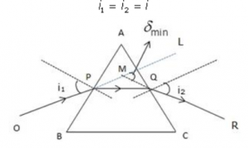

Question 13
A light ray of yellow colour is incident on an equilateral glass prism at an angle of incidence equal to 48º and suffers minimum deviation by an angle of 36º. (i) What will be the angle of emergence? (ii) If the angle of incidence is changed to (a) 30º, (b) 60º, state whether the angle of deviation will be equal to less than or more than 36º.

Answer 13
(i) As the ray is suffering minimum deviation in an equilateral glass prism so
(ii) If the angle of incidence is changed to
(a) 30º, the angle of deviation will be more than 36º.
(b) 60º, the angle of deviation will be more than 36º.

Question 14
Name the colour of white light which is deviated (i) the most, (ii) the least, on passing through a prism.

Answer 14
(i) Violet colour will deviate the most and (ii) Red colour will deviate the least.

Question 15
Which of the two prisms, A made of crown glass and B made of flint glass, deviate a ray of light more?

Answer 15
B made of flint glass. Because it has higher refractive index.

Question 16
How does the angle of deviation depend on refracting angle of the prism?

Answer 16
The angle of deviation () increases with the increase in the angle of prism (A).

Question 17
An object is viewed through a glass prism with its vertex pointing upwards. Draw a ray diagram to show the formation of its image seen by the observer.

Answer 17
Let two rays OA and OL from a source O are incident on the prism. They are refracted along AB and LM from first face of the prism. These two rays again refract from the second face of the prism emerge out along BC and MN respectively such that they appear to come from I.
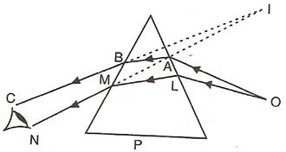
Thus, observer sees the object O raised to the position I.

Question 18
A ray of light is normally incident on one face of an equilateral glass prism. Answer the following:
(a)What is the angle of incidence on the first face of the prism?
(b)What is the angle of refraction from the first face of the prism?
(c)What will be the angle of incidence at the second face of the prism?
(d)Will the light ray suffer minimum deviation by the prism?

Answer 18
(a)If the incident ray normal to prism then angle of incidence is 0º.
(b)In this case the angle of refraction from the first face r₁= 0º.
(c)As the prism is equilateral so A=60º and r₁=0º. So at the second face of the prism, the angle of incidence will be 60º.
(d)No the light will not suffer minimum deviation.

Question 19
The diagram below 4.35 shows two identical prisms A and B placed with their faces parallel to each other. A ray of light of single colour PQ is incident at the face of the prism A. Complete the diagram to show the path of the ray till it emerges out of the prism B.
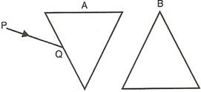
[Hint: The emergent ray out of the prism B will be parallel to the incident ray PQ]

Answer 19
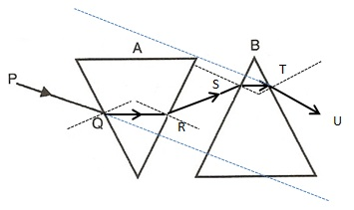

Refraction of Light at Plane Surfaces “Selina Solution
Multiple Choice Type 4(B)

Question 1
In refraction of light through a prism, the light ray:
(a) Suffers refraction only at one face of the prism
(b) Emerges out from the prism in a direction parallel to the incident ray
(c) Bends at both the surfaces of prism towards its base
(d) Bends at both the surfaces of prism opposite to its base.

Answer 1
The light ray bends at both the surfaces of prism towards its base.

Question 2
A ray of light suffers refraction through an equilateral prism. The deviation produced by the prism does not depend on the:
(a) Angle of incidence
(b) Colour of light
(c) Material of prism
(d) Size of prism

Answer 2
The deviation produced by the prism does not depend on the size of prism.

Refraction of Light at Plane Surfaces “Selina Solution
Numericals 4(B)

Question 1
A ray of light incident at an angle 48º on a prism of refracting angle 60º suffers minimum deviation. Calculate the angle of minimum deviation.
[Hint: δ_{min} = 2i – A]

Answer 1
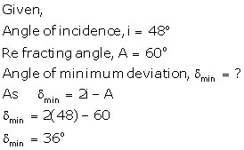

Question 2
What should be the angle of incidence for a ray of light which suffers a minimum deviation of 36º through an equilateral prism?
[Hint: A = 60°, i = (A + δ_{min})/2]

Answer 2
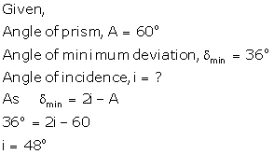

Exercise – 4(C) Selina Solutions ICSE Class-10 Refraction of Light at Plane Surfaces

Question 1
How is the refractive index of a medium related to the real and apparent depths of an object in that medium?

Answer 1
Relation of refractive index with real and apparent depths
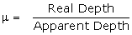

Question 2
Prove that
Refractive index = 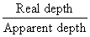

Answer 2
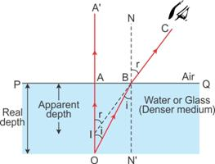
Consider a ray of light incident normally along OA. It passes straight along OAA’. Consider another ray from O (the object) incident at an angle i along OB. This ray gets refracted and passes along BC. On producing this ray BC backwards, it appears to come from the point I, and hence, AI represents the apparent depth, which is less than the real depth AO.
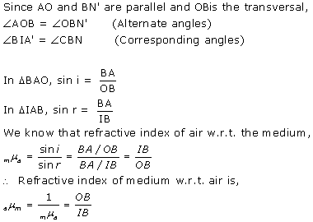
Since the point B is very close to point A, i.e. the object is viewed from a point vertically above the object,
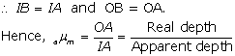

Question 3
A tank of water is viewed normally from above.
(a) State how the depth of tank appears to change.
(b) Draw a labelled ray diagram to explain your answer.

Answer 3
The depth of the tank appears to be lesser than its real depth. This happens due to the refraction of light from a denser medium (water) to a rarer medium.
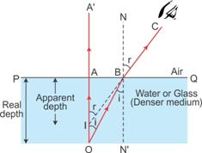

Question 4
Water in a pond appears to be only three-quarters of its actual depth. (a) What property of light is responsible for this observation? Illustrate your answer with the help of a ray diagram. (b) How is the refractive index of water calculated from its real and apparent depths?

Answer 4
‘Refraction of light’ is responsible for this property.
When light coming from denser medium enters rarer medium, it is bent away from the normal.
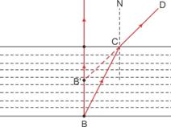
Let any object B is at the bottom of a pond. Consider a light ray BC from the object that moves from water to air. After refraction from the water surface, the ray moves away from the normal N along the path CD. The produce of CD appears from the point B’ and a virtual image of the object at B appears at B’.
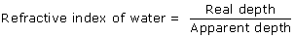

Question 5
Draw a ray diagram to show the appearance of a stick partially immersed in water. Explain your answer.

Answer 5
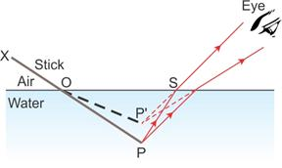
A stick partially immersed in water in a glass container appears bent or raised as shown in figure above. This happens because the rays appear to come from P’ (which is the virtual image of the tip P of the stick) due to refraction from denser medium (water) to rarer medium (air) at the surface separating two media.

Question 6
A fish is looking at a 1.0 m high plant at the edge of the pond. Will the plant appear shorter or taller than its actual height ? Draw a ray diagram to support your answer.

Answer 6
The plant will look taller than its actual height.
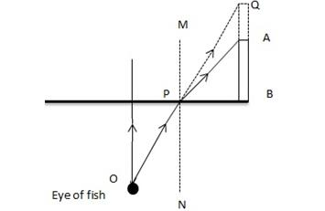

Let the fish is looking from the point O. As the ray OP emerges out from water to air, it will bend away from the normal MN because air is a rarer medium in comparison of water. But if we extend ray OP then it will meet at Q due to which the plant AB will look taller than its actual height.

Question 7
A student puts his pencil into an empty trough and observes the pencil from the position indicated in the diagram alongside in Fig. 4.41
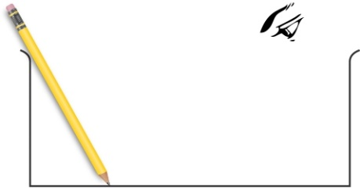

(i) What change will be observed in the appearance of the pencil when water is poured into the trough?
(ii) Name the phenomenon which accounts for the above started observation.
(iii) Complete the diagram showing how the student’s eye sees the pencil through water.

Answer 7
(i)Part of the pencil which is immersed in water will look short and raised up.
(ii)The phenomena which is responsible for the above observation is refraction of light.
(iii)The required figure is
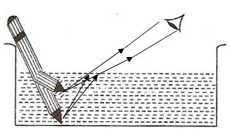

Question 8
An object placed in one medium when seen from the other medium, appears to be vertically shifted. Name the factors on which the magnitude of shift depends and state how does it depend on them.

Answer 8
The factors on which the magnitude of shift depends are:
(a)The refractive index of the medium,
(b)The thickness of the denser medium and
(c)The colour (or wavelength) of incident light.
The shift increase with the increase in the refractive index of medium. It also increases with the increase in thickness of denser medium but the shift decreases with the increases in the wavelength of light used.

“Selina Solution Refraction of Light at Plane Surfaces

Multiple Choice Type 4 (C)

Question 1
A small air bubble in a glass block when seen from above appears to be raised because of:
(a) Refraction of light
(b)Reflection of light
(c) Reflection and refraction of light
(d) None of the above

Answer 1
Refraction of light
Hint: When a ray of light travels from denser to rarer medium, it moves away from the normal.

Question 2
An object in a denser medium when viewed from a rarer medium appears to be raised. The shift is maximum for:
(a) Red light
(b) Violet light
(c) Yellow light
(d) Green light

Answer 2
The shift is maximum for violet light.
Hint: The shift is maximum for violet light because the refractive index of glass is the most for the violet light and apparent = (real depth)/(refractive index)

Refraction of Light at Plane Surfaces – Selina Concise ICSE Physics Solutions

Numericals- 4 (C)

Question 1
A water pond appears to be 2.7 m deep. If the refractive index of water is 4/3, find the actual depth of the pond.

Answer 1
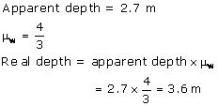

Question 2
A coin is placed at the bottom of a beaker containing water (refractive index = 4/3) to a depth of 12 cm. By what height the coin appears to be raised when seen from vertically above?

Answer 2
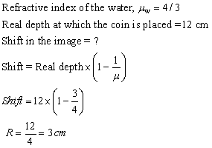

Question 3
A postage stamp kept below a rectangular glass block or refractive index 1.5 when viewed from vertically above it, appears to be raised by 7.0 mm. Calculate the thickness of the glass block.

Answer 3
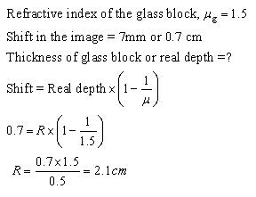

Refraction of Light at Plane Surfaces – Selina Solution

Exercise 4 (D)

Question 1
Explain the term critical angle with the aid of a labelled diagram.

Answer 1
Critical angle: The angle of incidence in the denser medium corresponding to which the angle of refraction in the rarer medium is 90º is called the critical angle.
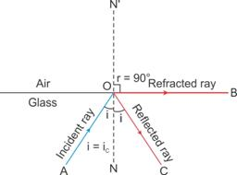

Question 2
How is the critical angle related to the refractive index of a medium?

Answer 2
The critical angle is related to the refractive index of a medium by the relation
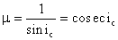

Question 3
State the approximate value of the critical angle for
(a) glass-air surface (b) water-air surface.

Answer 3
(a) The critical angle for glass-air surface is
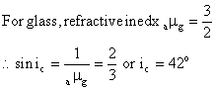
(b) The critical angle for water-air surface is
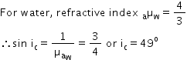

Question 4
What is the meant by the statement ‘the critical angle for diamond is 24°?

Answer 4
The critical angle for diamond is 24°. This implies that at an incident angle of 24° within the diamond the angle of refraction in the air will be 90°. And if incident angle will be more than this angle then the ray will suffer total internal reflection without any refraction.

Question 5
A light ray is incident from a denser medium on the boundary separating it from a rarer medium at an angle of incidence equal to the critical angle. What is the angle of refraction for the ray?

Answer 5
When a ray is incident from a denser medium to a rarer medium at angle equal to critical angle ( ), the angle of refraction becomes 90°.

Question 6
Name two factors which affect the critical angle for a given pair of media. State how do the factors affect it.

Answer 6
The factors which affect the critical angle are:
(i)The colour (or wavelength) of light, and
(ii)The temperature
(i)Effect of colour of light: The critical angle for a pair of media is less for the violet light and more for the red light. Thus critical angle increases with increase in wavelength of light.
(ii)Effect of temperature: The critical angle increases with increase in temperature because on increasing the temperature of medium, its refractive index decreases.

Question 7
The critical angle for glass-air is 45° for the light of yellow colour. State whether it will be less than, equal to, or more than 45° for (i) red light, (ii) blue light?

Answer 7
As the wavelength decreases (or increases) refractive index becomes more (or less) and critical angle becomes less (or more).
(i)For red light the critical angle will be more than 45° and
(ii)For blue light the critical angle will be less than 45°.

Question 8
(a)What is total internal reflection?
(b)State two conditions necessary for total internal reflection to occur.
(c)Draw diagrams to illustrate critical angle and total internal reflection.

Answer 8
(a)Total internal reflection: It is the phenomenon when a ray of light travelling in a denser medium, is incident at the surface of a rarer medium such that the angle of incidence is greater than the critical angle for the pair of media, the ray is totally reflected back into the denser medium.
(b)The two necessary conditions for total internal reflection are:
i.The light must travel from a denser medium to a rarer medium.
ii.The angle of incidence must be greater than the critical angle for the pair of media.
(c)When incidence angle is more than critical angle i.e., in case of total internal reflection.

Question 9
Fill in the blanks to complete the following sentences:
(a)Total internal reflection occurs when a ray of light passes from a ………………..medium to a …………………. medium.
(b)Critical angle is the angle of ……………..in denser medium for which the angle of …………………in rarer medium is ………………

Answer 9
(a)Total internal reflection occurs when a ray of light passes from a denser medium to a rarer medium.
(b)Critical angle is the angle of incidence in denser medium for which the angle of refraction in rarer medium is 90°.

Question 10
State whether the following statement is true or false: If the angle of incidence is greater than the critical angle, light is not refracted at all, when it falls on the surface from a denser medium to a rarer medium.

Answer 10
True

Question 11
The refractive index of air with respect to glass is expressed as 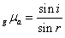
(a)Write down a similar expression for in terms of angle .
(b)If angle, what is the corresponding angle i called?
(c)What is the physical significance of the angle i and part (b)?

Answer 11
(a)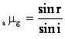
(b)If refractive angle, , the corresponding angle of incidence, i will be equal to critical angle.
(c)If the angle of incidenceexceeds the value of i obtained in part (b) (i.e., critical angle), total internal reflection will occur.

Question 12
Fig.4.61 below show two rays A and B travelling from water to air. If the critical angle for water- air surface is 48°, complete the ray diagram showing the refracted rays for each. State conditions when the ray will suffer total internal reflection.
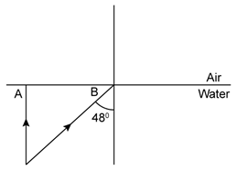

Answer 12
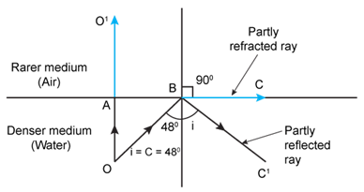
The necessary conditions for the total internal reflection to occur are
(i) Light must travel from a denser medium to a rarer medium.
(ii) The angle of incidence must be greater than the critical angle.
In this case, the angle of incidence.

Question 13
Fig. 4.62 shows a point source P inside a water container. Three rays A, B and C starting from the source P are shown up to the water surface.
(a) Show in the diagram, the path of these rays after striking the water surface. The critical angle for water-air surface is 48°.
(b) Name the phenomenon which the rays A, B and C exhibit.
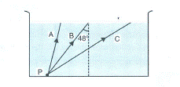

Answer 13
(a)
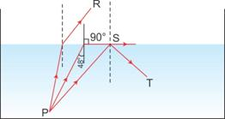
(b) Rays A and B exhibit the phenomenon of ‘refraction of light’.
Rays C exhibits the phenomenon of ‘total internal reflection’.

Question 14
In the figure, 4.63 PQ and PR are the two light rays emerging from an object P. The ray PQ is refracted as QS.
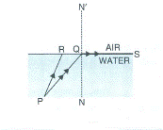
(a) State the special name given to the angle of incidencePQN of the ray PQ.
(b) What is the angle of refraction for the refracted ray QS?
(c) Name the phenomenon that occurs if the angle of incidencePQN is increased.
(d) The ray PR suffers partial reflection and refraction on the water-air surface. Give reason. Draw in the diagram the refracted ray for the incident ray PR and hence show the position of image of the object P by the letter P’ when seen vertically from above.

Answer 14
(a) Critical angle
Hint: The angle of incidence in the denser medium for which the angle of refraction in rarer medium is 90º is called the critical angle.
(b) 90º
(c) Total internal reflection.
Hint: When the angle of incidence is greater than the critical angle, the phenomenon of total internal reflection occurs due to which the ray of light is not refracted but is reflected back in the same medium.
(d) For the ray PR, the angle of incidence is less than the critical angle (i.e. ); hence, at the interface of two media as per the laws of reflection, ray PR suffers partial reflection and refraction.
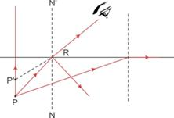

Question 15
The refractive index of glass is 1.5. From a point P inside a glass block, draw rays PA, PB and PC incident on that glass-air surface at an angle of 30º, 42º and 60º respectively.
(a)In the diagram show the approximate direction of these rays as they emerge out of the block.
(b)What is the angle of refraction for the ray PB?

Answer 15
(a)
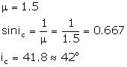
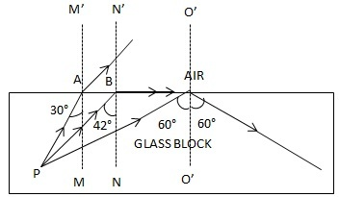
(b)
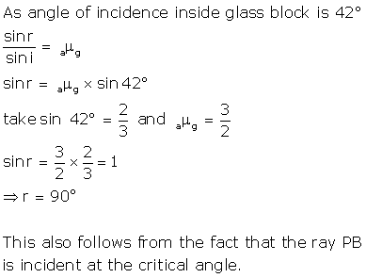

Question 16
A ray of light enters a glass ABCD as shown in Fig. and strikes at the Centre O of the circular part AC of the slab. The critical angle of glass is 42°. Complete the path of the ray till it emerges out of the slab. Mark the angles in the diagram wherever necessary.
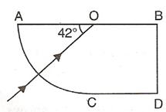

Answer 16
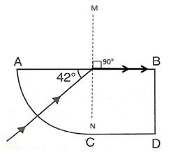
The angle of refraction will be 90° because the ray is incident on the glass at its critical angle.

Question 17
What is a total reflecting prism? State three actions that it can produce. Draw a diagram to show one action of the total reflecting prism.

Answer 17
A prism having an angle of 90° between its two refracting surfaces and the other two angles each equal to 45°, is called a total reflecting prism. The light incident normally on any of its faces, suffers total internal reflection inside the prism.
Due to this behavior, a total reflecting prism is used to produce following three actions:
(a)To deviate a ray of light through 90°,
(b)To deviate a ray of light through 180°, and
(c)To erect the inverted image without producing deviation in its path.
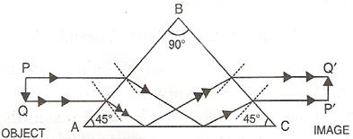
It is an erecting prism which is used to erect the inverted image without producing deviation in its path.

Question 18
Show with the help of a diagram how a total reflecting prism can be used to turn a ray of light through 90°. Name one instrument in which such a prism is used.

Answer 18
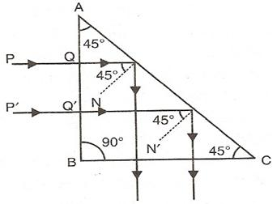
As shown in diagram, a beam of light is incident on face AB of the prism normally so it passes undeviated and strikes the face AC where it makes an angle of 45° with the normal to AC. Because here the incident angle is more than critical angle so rays suffer total internal reflection and reflect at angle of 45°. The beam then strikes face BC, where it is incident normally and so passes undeviated. As a result the incident beam gets deviated through 90°.
Such a prism is used in periscope.

Question 19
A ray of light OP passes through a right angled prism as shown in the adjacent diagram.
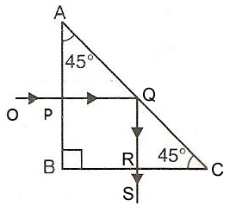
(a)State the angle of incidence at the faces AC and BC.
(b)Name the phenomenon which the ray suffers at the face AC.

Answer 19
(a)The angle of incidence at the face AC is 45° and angle of incidence at the face BC is 0°.
(b)The ray suffers total internal reflection at the face AC.

Question 20
In Fig., 4.66 a ray of light PQ is incident normally on the hypotenuse of an isosceles right angle prism ABC.
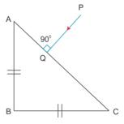
(a) Complete the path of the ray PQ until it emerges from the prism. Mark in the diagram the angle wherever necessary.
(b) What is the angle of deviation of the ray PQ?
(c) Name a device in which this action is used.

Answer 20
(a)
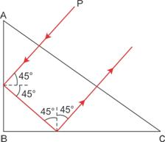
(b) Angle of deviation = 180º
(c) Prism binocular

Question 21
In Fig., a ray of light PQ is incident normally on the face AB of an equilateral glass prism. Complete the ray diagram showing its emergence into air after passing through the prism.
Take critical angle for glass = 42°
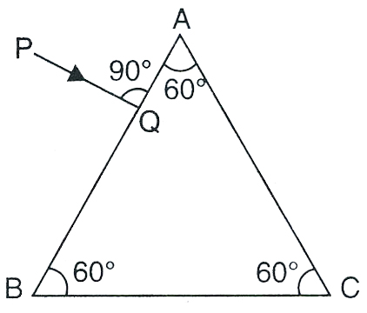
(a)Write the angles of incidence at the faces AB and AC of the prism.
(b)Name the phenomenon which the ray of light suffers at the face AB, AC and BC of the prism.

Answer 21
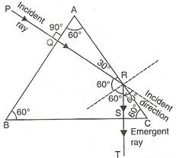
(a)At the face AB,and at the face AC,.
(b)At the face AB – refraction,
and At the face AB – total internal reflection,
while At the face BC – refraction.

Question 22
Draw a neat labelled ray diagram to show the total internal reflection of a ray of light normally incident on one face of a 30°, 90°,60° prism.

Answer 22
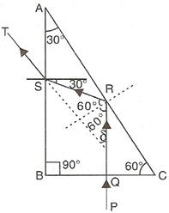

Question 23
Two isosceles right – angled glass prisms are placed near each other as shown in Fig. Complete the path of the light ray entering the first prism till it emerges out of the second prism.
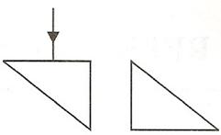

Answer 23
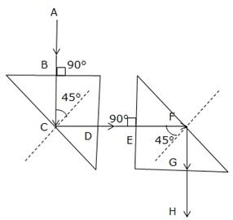

Question 24
What device other than a plane mirror, can be used to turn a ray of light 180°? Draw a diagram in support of your answer. Name an instrument in which in which this device is used.

Answer 24
A total reflecting prism can be used to turn a ray of light by 180°. The following diagram can make it further clear.
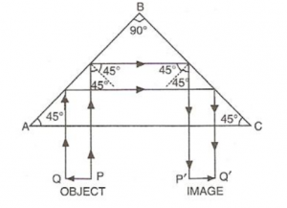
This action of prism is used in binocular.

Question 25
Mention one difference between reflection of light from a plane mirror and total internal reflection of light from a prism.

Answer 25
When total internal reflection occurs from a prism, the entire incident light (100%) is reflected back into the denser medium. Whereas in ordinary reflection from a plane mirror, some light is refracted and absorbed so the reflection is partial.

Question 26
State one advantage of using a total reflecting prism as a reflector in place of a plane mirror.

Answer 26
A total reflecting prism gives us an image much brighter than that obtained by using a plane mirror.

Refraction of Light at Plane Surfaces – Selina ICSE Physics Solution

Multiple Choice Type 4(D)

Question 1
The critical angle for glass-air interface is :
(a) 24°
(b) 48°
(c) 42°
(d) 45°

Answer 1
42°

Question 2
A total reflecting right angled isosceles prism can be used to deviate a ray of light through
(a) 30°
(b) 60°
(c) 75°
(d) 90°

Answer 2
90°
Hint:
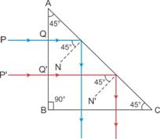

Question 3
A total reflecting equilateral prism can be used to deviate a ray of light through:
(a) 30°
(b) 60°
(c) 75°
(d) 90°

Answer 3
60°
Hint:
