NCERTPREP.COM

Refraction Through Lens “Selina Physics Solution”

Exercise – 5 (A)

Question 1
What is a lens?

Answer 1
A lens is a transparent refracting medium bounded by two curved surfaces which are generally spherical.

Question 2
Name the two kinds of lens? Draw diagrams to illustrate them.

Answer 2
Lenses are of two types :
(i)Convex or converging lens,
(ii)Concave or diverging lens.

Question 3
State difference between a convex and a concave lens in their (a) appearence, and (b) action on the incident light.

Answer 3
Convex lens:
(a) Thick in the middle thinner at the edges.
(b)
(i)It converge the incident rays towards the principal axis.
(ii)It has a real focus.
Concave lens:
(a) Thin in the middle thicker at the edges.
(i)It diverges the incident rays away from the principal axis.
(ii)It has a virtual focus.

Question 4
Which lens is converging: (i) an equiconcave lens or an equiconvex lens?(ii)
A concavo-convex lens or a convexo-concave lens?

Answer 4
(a) Equiconvex lens is converging.
(b) The concavo-convex lens is a converging lens. This is because it is thicker at the middle and thinner at edges allowing it to converge all the light that is incident on it.

Question 5
Out of the two lenses, one concave and the other convex, state which one will show the divergent action on a light beam. Draw diagram to illustrate your answer.

Answer 5
Concave lens will show the divergent action on a light beam.

Question 6
Show by a diagram the refraction of two light rays incident parallel to the principal axis on a convex lens by treating it as a combination of a glass slab and two triangular glass prisms.

Answer 6
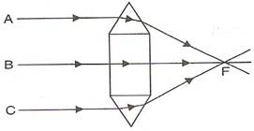
As shown in the figure the convex lens has two glass prisms and one glass slab. One of the glass prisms is situated above the glass slab and one below the slab.

Question 7
Show by a diagram the refraction of two light rays incident parallel to the principal axis on a concave lens by treating it as a combination of a glass slab and two triangular glass prisms.

Answer 7
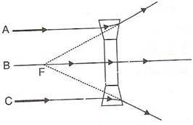
As shown in the figure the concave lens has two glass prisms and one glass slab. One of the glass prisms is situated above the glass slab and one below the slab.

Question 8
How does the action of convex lens differ from that of a concave lens on a parallel beam of light incident on them? Draw diagrams to illustrate your answer.

Answer 8
If a parallel beam of light is incident on a convex lens then the upper part of the lens bends the incident ray downwards. The lower part bens the ray upwards while the central part passes the ray undeviated.
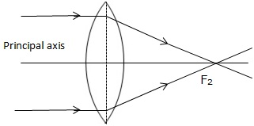
Convex lens
But in case of a concave lens the upper part of the lens bends the incident ray upwards and lower part bends the ray downwards while the central part passes the ray undeviated.
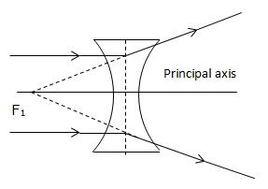
Concave lens

Question 9
Define the term principal axis of a lens.

Answer 9
It is the line joining the centers of curvature of the two surfaces of the lens.

Question 10
Explain optical centre of a lens with the help of a proper diagram(s).

Answer 10
It is point on the principal axis of the lens such that a ray of light passing through this point emerges parallel to its direction of incidence.
It is marked by letter O in the figure. The optical centre is thus the centre of the lens.
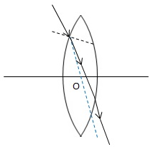

Question 11
A ray of light incident on a point on the principal axis of a convex lens, passes undeviated through the lens. (a) What special name is given to this point on the principal axis? (b) Draw a labelled diagram to support answer in part(a).

Answer 11
(a) This point is known as Optical centre.
(b)
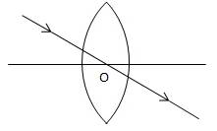

Question 12
State the condition when a lens is called an equiconvex or equiconcave.

Answer 12
A lens is called an equiconvex or equiconcave when radii of curvature of the two surfaces of lens are equal.

Question 13
Define the term principal foci of a convex lens and illustrate your answer with the aid of proper diagrams.

Answer 13
A light ray can pass through a lens from either direction. Therefore, a lens has two principal foci.
For a convex lens, the first focal point is a point F₁ on the principal axis of the lens such that the rays of light starting from it or passing through it, after refraction through lens, become parallel to the principal axis of the lens.
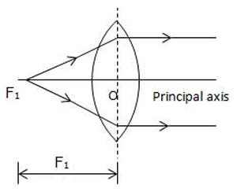
The second focal point for a convex lens is a point F₂ on the principal axis such that the rays of light incident parallel to the principal axis, after refraction from the lens, pass through it.
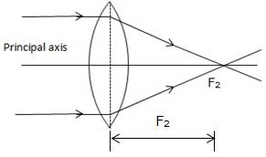

Question 14
Define the term principal foci of a concave lens and show them with the help of proper diagrams.

Answer 14
A light ray can pass through a lens from either direction. Therefore, a lens has two principal foci.
For a concave lens, the first focal point is a point F₁ on the principal axis of the lens such that the incident rays of light appearing to meet at it, after refraction from the lens become parallel to the principal axis of the lens.
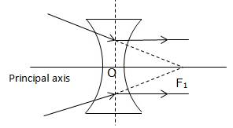
The second focal point for a concave lens is a point F₂ on the principal axis of the lens such that the rays of light incident parallel to the principal axis, after refraction from the lens, appear to be diverging from this point.
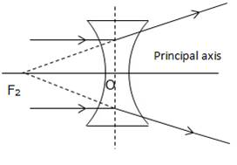

Question 15
Draw a diagram to represent the second focus of a concave lens.

Answer 15
Concave lens representing second focus

Question 16
Draw a diagram to represent the second focus of a convex lens.

Answer 16
Convex lens representing second focus

Question 17
A ray of light, after refraction trough a concave lens emerges parallel to the principal axis.
(a) Draw a ray diagram to show the incident ray and its corresponding emergent ray.
(b) The incident ray when produced meets the principal axis at a point. Name the point F.

Answer 17
(a)

(b) The point where incident ray when produced meets the principal axis is called first focus.

Question 18
A ray of light after refraction through a convex lens emerges parallel to the principal axis. (a) Draw a ray diagram to show it. (b) The incident ray passes through a point F on the principal axis. Name the point F.

Answer 18
(a)
(b) The point where incident ray passes through a point on the principal axis is called first focus.

Question 19
A beam of light incident on a convex lens parallel to its principal axis converges at a point F on the principal axis. Name the point F. Draw a ray diagram to show it.

Answer 19
Such a point will be second focus.

Question 20
A beam of light incident on a thin concave lens parallel to its principal axis diverges and appears to come from a point F on the principal axis. Name the point F. Draw a ray diagram to show it.

Answer 20
It appears to come from ‘Second Focus’.
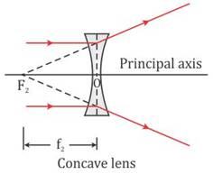

Question 21
Define the term focal length of a lens.

Answer 21
The distance from the optical centre O of the lens to its second focal point is called the focal length of the lens.

Question 22
What do you mean by focal plane of a lens?

Answer 22
A plane passing through the focal point and normal to the principal axis of the lens is called the first focal plane.

Question 23
State the condition for each of the following :
(a)a lens has both its focal length equal.
(b)a ray passes undeviated through the lens.

Answer 23
(a) If a lens has both its focal length equal medium is same on either side of lens.
(b) If a ray passes undeviated through the lens it is incident at the optical centre of the lens.

Question 24
A parallel oblique beam of light falls on a (i) convex lens, (ii) concave lens. Draw a diagram in each case to show the refraction of light through the lens.

Answer 24
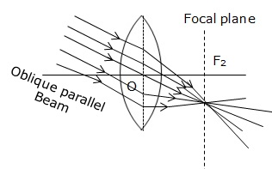
Refraction of an oblique parallel beam by a convex lens.

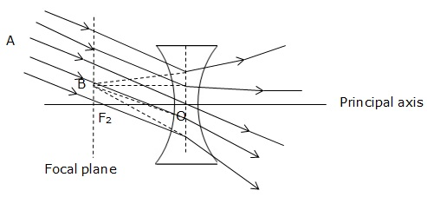
Refraction of an oblique parallel beam by a concave lens

Question 25
The diagram below shows a lens as a combination of a glass block and two prisms
.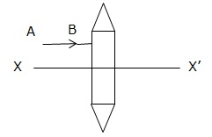
(i)Name the lens formed by the combination.
(ii)What is the line XX’ called?
(iii)Complete the ray diagram and show the path of the incident ray AB after passing through the lens.
(iv)The final emergent ray will either meet XX’ at a point or appear to come from a point on XX’. Label the point as F. What is this point called?

Answer 25
(i)The combination forms convex lens.
(ii)XX’ is known as principal axis.
(iii)The complete diagram is
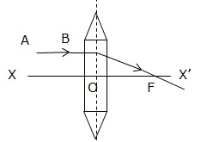
(iv)The point F is called as Focal point or focus.

Question 26
The diagram below shows a lens as a combination of a glass block and two prisms.
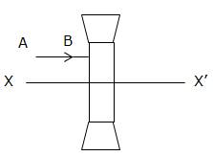

(i) Name the lens formed by the combination.
(ii) What is the line XX’ called?
(iii) Complete the path of the incident ray AB after passing through the lens.
(iv) The final emergent ray either meets XX’ at a point or appears to come from a point on XX’. Label it as F. What is this point called

Answer 26
(i) The combination forms concave lens.
(ii) XX’ is known as principal axis.
(iii) Complete diagram is drawn as
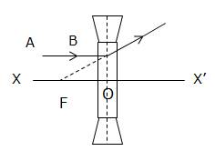
(iv) The point F is called as Focal point or focus.

Question 27
In Fig. 5.17 (a) and (b), F₁ and F₂ are the positions of the two foci of the thin lenses. Draw the path taken by the light ray AB after it emerges from the lens.
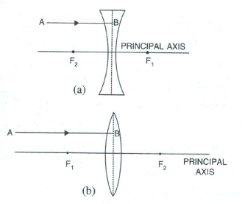

Answer 27
(a)
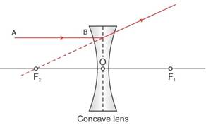
(b)
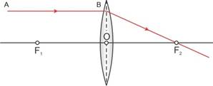

Question 28
In Fig 5.18 . (a) and (b), F₁ and F₂ are the two foci of the thin lenses and AB is the incident ray. Complete the diagram to show the path of the ray AB after refraction through the lens.
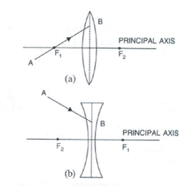

Answer 28

(a)
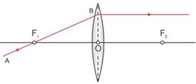

(b)
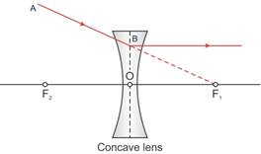

Question 29
Complete the following sentences :
(a) If half part of a convex lens is covered, the focal length __________ change, but the intensity of image _________.
(b) A convex lens is placed in water. Its focal length will ________.
(c)The focal length of a thin convex lens is _________ than that of a thick convex lens.

Answer 29
(a) If half part of a convex lens is covered, the focal length does not change, but the intensity of image decreases.
(b) A convex lens is placed in water. Its focal length will increase.
(c) The focal length of a thin convex lens is more than that of a thick convex lens.

Refraction Through Lens Chapter-5

Multiple Choice Type – 5 ( A)

Question 1
A ray of light after refraction through a lens emerges parallel to the principal axis of the lens. The incident ray either passes through :
(a) its optical centre
(b) its first focus
(c) its second focus
(d) its centre of curvature of the first surface

Answer 1
(b) its first focus

Question 2
A ray of light incident on a lens parallel to its principal axis, after refraction passes through or appears to come from:
(a) Its first focus
(b) Its optical entre
(c) Its second focus
(d) The centre of curvature of its second surface
Answer 2
(C) Its second focus

Refraction Through Lens ( Selina Solution )

Exercise – 5( B)

Question 1
What are the three principal rays that are drawn to construct the ray diagram for the image formed by a lens? Draw diagram to support your answer.

Answer 1
(i) A ray of light incident at the optical centre O of the lens passes undeviated through the lens.
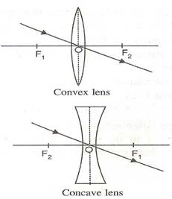

(ii) A ray of light incident parallel to the principal axis of the lens, after refraction passes through the second focus F₂ (in a convex lens) or appears to come from the second focus F₂ (in a concave lens).
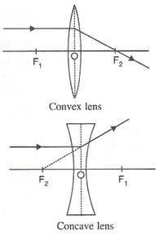
(iii) A ray of light passing through the first focus F₁ (in a convex lens) or directed towards the first focus F₁ (in a concave lens), emerges parallel to the principal axis after refraction.
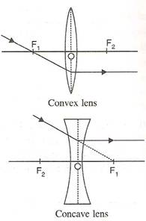

Question 2
In the diagrams below, XX’ represents the principal axis, O the optical centre and F the focus of the lens. Complete the path of rays A and B as they emerge out of the lens.
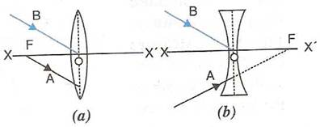

Answer 2
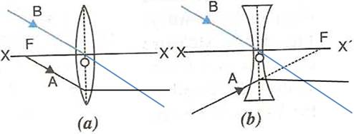

Question 3
Where must a point source of light be placed in front of a convex lens so as to obtain a parallel beam of light?

Answer 3
If the point source of light is placed at the ‘first focal point’ (i.e. the focal point on the left of the optical centre of the convex lens), then the rays of light after being refracted through the length obtain a parallel beam of light.

Question 4
Distinguish between a real and a virtual image.

Answer 4
Real image | Virtual image
1.A real image is formed due to actual intersection of refracted (or reflected) rays. | 1A virtual image is formed when the refracted (or reflected) rays meet if they are produced backwards.
2A real image can be obtained on a screen. | 2.A virtual image can not be obtained on a screen.
3.A real image is inverted with respect to the object. | 3.A virtual image is erect with respect to the object.

Answer 5
Study the diagram given below.
(a) Name the lens LL’.
(b) What are the points O and O’ called?
(c) Complete the diagram to form the image of the object AB.
(d) State the three characteristics of the image.
(e) Name a device in which this action of lens is used.
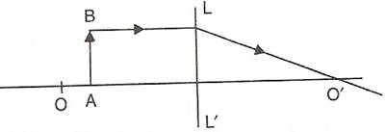

Answer 5
(a) LL’ lens is convex lens.
(b) O and O’ are known as first and second focal points respectively.
(c)
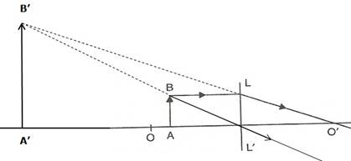

(d) The image formed will be magnified, virtual and upright.
(e) Such action of lens is used in a magnifying glass.

Question 6
Study the diagram below.
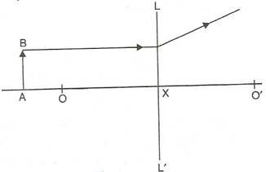
(i)Name the lens LL’.
(ii)What are the points O, O’ called?
(iii)Complete the diagram to from the image of the object AB.
(iv)State three characteristics of the image.

Answer 6
(i) LL’ is concave lens.
(ii)The points O and O’ are called second and first focal points respectively.
(iii)
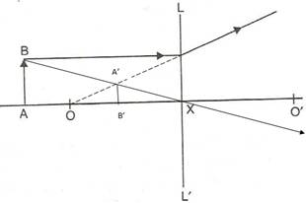
(iv)The three characteristics of the image are :
Virtual
Erect
Diminished

Question 7
The following diagram in Fig.5.50 shows an object AB and a converging lens L with foci F₁ and F₂.
(a) Draw two rays from the object AB and complete the diagram to locate the position of the image CD. Also mark on the diagram the position of eye from where the image can be viewed.
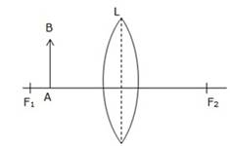
(b) State three characteristics of the image in relation to the object.

Answer 7
(a)The complete diagram is
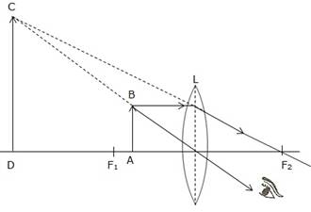
(b)The image formed will be magnified, virtual and upright.

Question 11
The diagram given below in fig. shows the position of an object OA in relation to a converging lens whose foci are at F₁ and F₂.
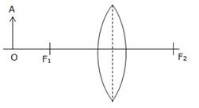
(i) Draw two rays to locate the position of the image.
(ii) State the position of image with reference to the lens.
(iii) Describe the three characteristics of the image.
(iv) Describe how the distance of the image from the lens and the size of the image change as the object move towards F₁.

Answer 8
(i)
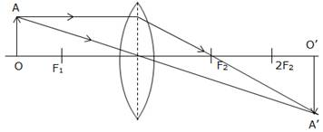
(ii) The position of the images will be more than twice the focal length of lens.
(iii) The image will be magnified, real and inverted.
(iv) As the object move towards F₁ the image will shift away from F₂ and it is magnified. At F₁ the image will form at infinity and it is highly magnified. Between F₁ and optical centre, the image will form on the same side of object and will be magnified.

Question 19
A converging lens forms the image of an object placed in front of it, beyond 2F₂ of the lens.
(a) Where is the object placed? (b) Draw a ray diagram to show the formation of image. (c) State its three characteristics of the image.

Answer 19
(a) The object is placed beyond 2F₁.
(b)
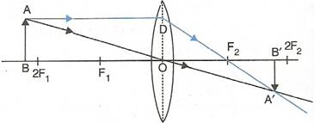
(c) The image is formed beyond 2F₂.
(d) The image will be diminished, real and inverted.

Question 10
A convex lens forms an image of an object equal to the size of the object. (a) Where is the object placed in front of the lens? (b) Draw a diagram to illustrate it. (c) State two more characteristics of the image.

Answer 10
(a) The object is placed at the centre of curvature.
(b)
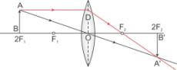
(c) The image formed is real and inverted.

Question 11
A lens forms an erect, magnified and virtual image of an object.
(a) Name the kind of lens.
(b) Where is the object placed in relation to the lens?
(c) Draw a ray diagram to show the formation of image.
(d) Name the device which uses this principle.

Answer 11
(a) Convex lens
(b) The object is placed between the lens and focus (F₁).
(c)
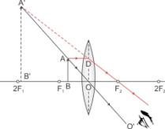
(d) ‘Magnifying glass’ uses this principle.

Question 12
A lens always forms an image between the object and the lens. (a) name the lens. (b) Draw a ray diagram to shown the formation of such image. (c) state three characteristics of the image.

Answer 12
(a) The lens that forms the image between the object and itself is a concave lens.
(b) Ray diagram:
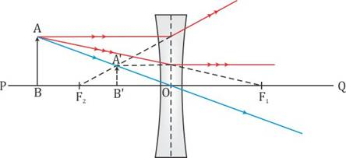
(c) The image formed is virtual, erect and diminished.

Question 13
Classify as real or virtual, the image of a candle flame formed on a screen by a convex lens. Draw a ray diagram to illustrate how the image is formed.

Answer 13
Let the candle is placed beyond 2F₁ and its diminished image which is real and inverted is formed between F₂ and 2F_{2.}
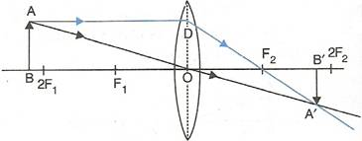
Here the candle is AB and its real and inverted image is formed between F₂ and 2F_{2.}

Question 14
Show by a diagram that a diverging lens cannot form a real image of an object placed anywhere on its principal axis.

Answer 14
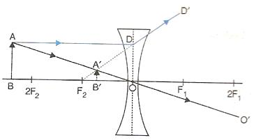

Question 15
Draw a ray diagram to show how a converging lens can form a real and enlarged image of an object.

Answer 15
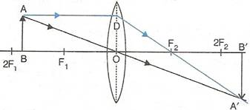
The image formed in above diagram is real, enlarged and inverted.

Question 16
A lens forms an upright and diminished image of an object placed at its focal point. Name the lens and draw a ray diagram to show the formation of image.

Answer 16
If a lens forms an upright and diminished image of an object placed at its focal point, then it is a concave lens.

Question 17
Draw a ray diagram to show how a converging lens is used as a magnifying glass to observe a small object. Mark on your diagram the foci of the lens and the position of the eye.

Answer 17
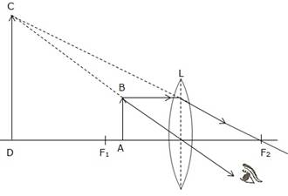
The object is placed between focal point F₁ and convex lens and its image is formed at the same side of the lens which is enlarged.
So this lens can be used as a magnifying lens.
Question 18
Draw a ray diagram to show how a converging lens is can form an image of the sun. Hence give a reason for the term ‘burning glass’ for a converging lens used in this manner.

Answer 18
The sun is at infinity so convex lens forms its image at second focal point which is real and very much diminished in size.
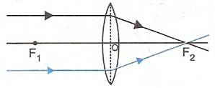
While using the convex lens as burning glass, the rays of light from the sun (at infinity) are brought to focus on a piece of paper kept at the second focal plane of the lens. Due to sufficient heat of the sun rays, the paper burns. Hence this lens is termed as ‘burning glass’.

Question 19
A lens forms an inverted image of an object.
(a) Name the kind of lens.
(b) State the nature of the image whether real or virtual?

Answer 19
(a) This is convex lens.
(b) The nature of the image is real.

Question 20
A lens forms an upright and magnified image of an object.
(a)Name the lens.
(b)Draw a labelled ray diagram to show the image formation.

Answer 20
(a)Convex lens.
(b)Virtual.

Question 21
(a)Name the lens which always forms an erect and virtual image.
(b)State whether the image in part (a) is magnified or diminished?

Answer 21
(a)Concave lens
(b)Image is diminished

Question 22
Can a concave lens form an image of size two times that of the object? Give reason?

Answer 22
A concave lens cannot form an image two times that of the object because it always forms a diminished image.

Question 23
Give two characteristics of the image formed by a concave lens.

Answer 23
Image formed by a concave lens is virtual and diminished.

Question 24
Give two characteristics of the virtual image formed by a convex lens.

Answer 24
The virtual image formed by a convex lens will be magnified and upright.

Question 25
In each of the following cases, where must an object be placed in front of a convex lens so that the image formed is
(a)at infinity,
(b)of same size as the object,
(c)inverted and enlarged,
(d)upright and enlarged?

Answer 25
(a)at focus,
(b)at 2F,
(c)between F and 2F,
(d)between optical centre and focus.

Question 26
Complete the following table:
Type  of  lens | Position  of  object | Nature of image | Size of image
Convex | Between  optic  centre  and  focus
Convex | At  focus
Concave | At  infinity
Concave | At any distance

Answer 26
Type  of  lens | Position  of object | Nature  of  image | Size  of  image
Convex | Between  optic  centre  and  focus | Virtual  and  upright | Magnified
Convex | At  focus | Real  and  inverted | Very  much magnified
Concave | At  infinity | Virtual  and  upright | Highly diminished
Concave | At  any  distance | Virtual  and  upright | Diminished
RELATED POSTS
Estimation ICSE Class-6th Concise Selina Maths Solutions
Apr 9, 2020
Integers ICSE Class-7th Concise Selina Maths Solutions
Apr 9, 2020

Question 27
State the changes in the position, size and nature of the image of an object when brought form infinity up to a convex lens. Illustrate your answer by drawing the ray diagrams.

Answer 27
(i)When the object is situated at infinity, the position of image is at F₂, it is very much diminished in size and it is real and inverted.
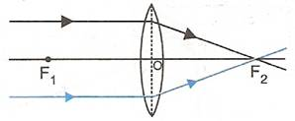
(ii)When the object (AB) is situated beyond 2F₁, the position of image (A’B’) is between F₂ and 2F₂, it is diminished in size and real and inverted.
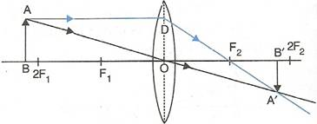
(iii)When the object (AB) is situated at 2F₁, the position of image (A’B’) is at 2F₂, it is of same size as the object and real and inverted.
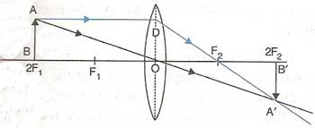
(iv)When the object (AB) is situated between 2F₁and F₁, the position of image (A’B’) is beyond 2F₂, it is magnified in size and real and inverted.
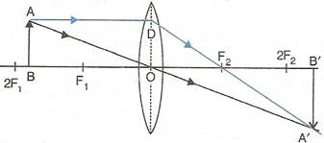
(v)When the object (AB) is situated at F₁, the position of image is at infinity; it is very much magnified in size and real and inverted.
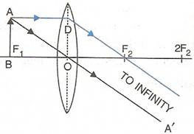
(vi)When the object (AB) is situated between lens and F₁, the position of image (CD) is on the same side, behind the object; it is magnified in size and virtual and upright.
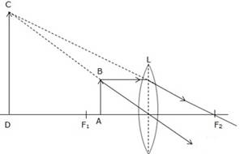

Question 28
State the changes in the position, size and nature of the image When the object is brought from infinity up to a concave lens. Illustrate your answer by drawing diagrams.

Answer 28
(i)When object (AB) is situated at infinity then parallel rays from object appears to fall on concave lens. Due to which image forms at focus. This image is highly diminished in size and virtual and upright.
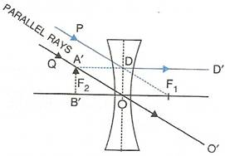
(ii)When object (AB) is situated at any point between infinity and optical centre of the lens then image forms between focus and optical centre. This image is diminished in size and virtual and upright.

Question 29
Complete the following sentences:
(a)An object is placed at a distance of more than 40 cm from a convex lens of focal length 20 cm. The image formed is real, inverted and…………….
(b)An object is placed at a distance 2f from a convex lens of focal length f. The image formed is…………….that of the object.
(c)An object is placed at a distance 5 cm from a convex lens of focal length 10 cm. The image formed is virtual, upright and…………..

Answer 29
(a)An object is placed at a distance of more than 40 cm from a convex lens of focal length 20 cm. The image formed is real, inverted and diminished.
(b)An object is placed at a distance 2f from a convex lens of focal length f. The image formed is equal to that of the object.
(c)An object is placed at a distance 5 cm from a convex lens of focal length 10 cm. The image formed is virtual, upright and magnified.

Question 30
State whether the following statements are ‘true’ or ‘false’ by writing T/F against them.
(a)A convex lens has a divergent action and a concave lens has a convergent action.
(b)A concave lens if kept at a proper distance from an object can form its real image.
(c)A ray of light incident parallel to the principal axis of a lens, passes undeviated after refraction.
(d)A ray of light incident at the optical centre of lens, passes undeviated after refraction.
(e)A concave lens forms a magnified or diminished image depending on the distance of object from it.

Answer 30
(a)False
(b)False
(c)False
(d)True
(e)False

Refraction Through Lens

Multiple Choice Type – 5(B)

Question 1
For an object placed at distance 20 cm in front of a convex lens, the image is at distance 20 cm behind the lens. The focal length of convex lens is:
(a) 20 cm
(b) 10 cm
(c) 15 cm
(d) 40 cm

Answer 1
The focal length of the convex lens is 10 cm.
Hint: As the object distance = image distance, the object must be kept at 2f.
Therefore, 2f = 20 cm or f = 10 cm.

Question 2
For the object placed between optical centre and focus of a convex lens, the image is:
(a) Real and enlarged
(b) Real and diminished
(c) Virtual and enlarged
(d) Virtual and diminished.

Answer 2
Virtual and enlarged.
Explanation: When the object is kept between optical centre and focus of a convex lens, the image is formed on the same side, behind the object. The image thus formed is virtual, enlarged and erect.

Question 3
A concave lens forms the image of an object which is:
(a) Virtual, inverted and diminished
(b) Virtual, upright and diminished
(c) Virtual, inverted and enlarged
(d) Virtual, upright and enlarged

Answer 3
Virtual, upright and diminished
Hint: Concave lens forms virtual, upright and diminished image for all positions of the object.

Refraction Through Lens ICSE Physics Solution

Exercise 5(C)

Question 1
State the sign convention to measure the distances for a lens.

Answer 1
The axis along which the distances are measured is called as the principal axis. These distances are measured from the optical centre of the lens.
All the distances which are measured along the direction of the incident ray of the light are taken positive, while the distances opposite to the direction of the incident ray are taken as negative.
and All the lengths that are measured above the principal axis are taken positive, while the length below the principal axis is considered negative.
The focal length of the convex lens is taken positive and that of concave lens is negative.

Question 2
The focal length of a lens is (i) positive, (ii) negative.
In each case, state the kind of lens.

Answer 2
(i) The positive focal length of a lens indicates that it is a convex lens.
(ii) The negative focal length of a lens indicates that it is a concave lens.

Question 3
Write the lens formula explaining the meaning of the symbols used.

Answer 3
Lens formula:
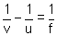
where The distance of the object from the optical centre is called the object distance (u).
and The distance of the image from the optical centre is called the image distance (v).
The distance of the principal focus from the optical centre is called the focal length (f).

Question 4
What do you understand by the term magnification? Write expression for it for a lens, explaining the meaning of the symbols used.

Answer 4
The term magnification means a comparison between the size of the image formed by a lens with respect to the size of the object.
For a lens: Magnification ‘m’ is the ratio of the height of the image to the height of the object.
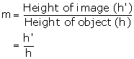

Question 5
What information about the nature of image (i) real or virtual, (ii) erect or inverted, do you get from the sign of magnification + or – ?

Answer 5
(i) Positive sign of magnification indicates that the image is virtual while negative sign indicates that the image is real.
(ii) Positive sign of magnification indicates that the image is erect while negative sign indicates that the image is inverted.

Question 6
Define the term power of a lens. In what unit is it expressed?

Answer 6
The power of a lens is a measure of deviation produced by it in the path of rays refracted through it.
Its unit is Dioptre (D).

Question 7
How is the power of a lens related to its focal length?

Answer 7
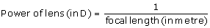

Question 8
How does the power of a lens change if its focal length is doubled?

Answer 8
If focal length of a lens doubled then its power gets halved.

Question 9
How is the sign (+ or -) of power of a lens related to its divergent or convergent action?

Answer 9
The sign of power depends on the direction in which a light ray is deviated by the lens. The power could be positive or negative. If a lens deviates a ray towards its centre (converges), the power is positive and if it deviates the ray away from its centre (diverges), the power is negative.

Question 10
The power of a lens is negative. State whether it is convex or concave?

Answer 10
It is a concave.

Question 11
Which lens has more power: a thick lens or a thin lens?

Answer 11
A thick lens has more power than a thin lens. This is because a thick lens has a larger surface curvature. It has a short focal lengthand that is why it deviates the rays of light at a greater extent.

Refraction Through Lens (Selina Publication )

Multiple Choice Type 5(C)

Question 1
If the magnification produced by a lens is – 0.5, the correct statement is :
(a) The lens is concave
(b) The image is virtual
(c) The image is magnified
(d) The images is real and diminished formed by a convex

Answer 1
Magnification is -0.5. The negative sign of magnification indicates that the image is real while 0.5 indicates that the image is diminished. A convex lens only forms a real and diminished image of an object. Hence, the correct answer is option (d).

Question 5
The correct lens formula is
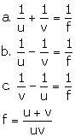

Answer 2
The correct lens formula is given by option (c).

Question 3
On reducing the focal length of a lens, its power:
(a) Decreases
(b) Increases
(c) Does not change
(d) First increases then decreases.

Answer 3
Increases
Hint 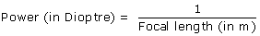

Question 4
The lens of power + 1.0 D is :
(a) convex of focal length 1.0 cm
(b) convex of focal length 1.0 m
(c) concave of focal length 1.0 cm
(d) concave of focal length 1.0 m

Answer 4
Power of a lens is +1.0 D. The positive sign indicates that the focal length of the lens is positive which indicates the lens is a convex lens.
Power is 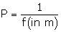
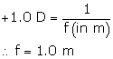
Hence, the correct answer is option (b).

Refraction Through Lens Selina Physics Solution

Numericals 5 (C)

Question 1
(a) At what position a candle of length 3 cm be placed in front of a convex lens so that its image of length 6 cm be obtained on a screen placed at distance 30 cm behind the lens?
(b) What is the focal length of lens in part (a)?

Answer 1
Height of the candle (object) = 3 cm
Height of the image of the candle = 6 cm
Image distance = 30 cm
(a) The formula for magnification of a lens is
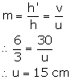
(b) Lens formula is
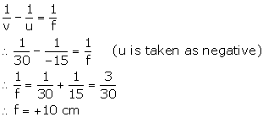

Question 2
A concave lens forms the image of an object kept at a distance 20 cm in front of it, at a distance 10 cm on the side of the object.
(a) What is the nature of the image?
(b) Find the focal length of the lens.

Answer 2
Object distance, u = -20 cm
Image distance, v = -10 cm
(a) The image is formed on the same side as the object. Hence, it is a virtual image. Also, since the lens is a concave lens the image will be erect and diminished.
(b) Lens formula is
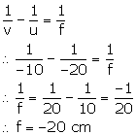

Question 3
The focal length of a convex lens is 25 cm. At what distance from the optical centre of the lens an object be placed to obtain a virtual image of twice the size?

Answer 3
Focal length, f = +25 cm
Image is virtual and magnified, m = +2
For a lens, magnification is
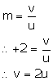
Lens formula is,
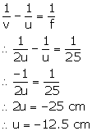

Question 4
Where should an object be placed in front of a convex lens of focal length 0.12 m to obtain a real image of size three times the size of the object, on the screen?

Answer 4
Focal length of a convex lens, f = +0.12 m
m = -3 (real image)
For a lens, magnification is
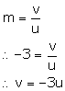
Lens formula is,
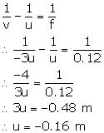

Question 5
An illuminated object lies at a distance 1.0 m from a screen. A convex lens is used to form the image of object on a screen placed at distance 75 cm from the lens. Find: (i) the focal length of lens, and (ii) the magnification.

Answer 5
Image distance, v = 75 cm
Object distance, u = -25 cm
Lens formula is,
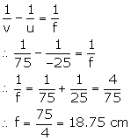
For a lens, magnification is
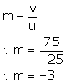

Question 6
A lens forms the image of an object placed at a distance 15 cm from it, at a distance 60 cm in front of it. Find: (i) the focal length, (ii) the magnification, and (iii) the nature of image.

Answer 6
Object distance, u = -15 cm
Image distance, v = -60 cm
(i) Lens formula is,
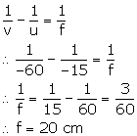
(ii) For a lens, magnification is
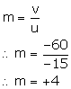
(iii) The nature of the image is erect, virtual and magnified.

Question 7
A lens forms the image of an object placed at a distance of 45 cm from it on a screen placed at a distance 90 cm on other side of it. (a) name the kind of lens. (b) find: (i) the focal length of lens, (ii) the magnification of image.

Answer 7
Object distance, u = -45 cm
Image distance, v = +90 cm
(a) As the image is formed on the other side of the lens, the image is real. Hence, the lens is a convex lens.
(b) (i) Lens formula is,
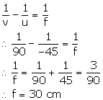
(ii) For a lens, magnification is
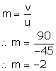

Question 8
An object is placed at a distance of 20 cm in front of a concave lens of focal length 20 cm. find: (a) the position of image, and (b) the magnification of image

Answer 8
Object distance, u = -20 cm
Focal length, f = -20 cm (concave lens)
(a) Lens formula is,
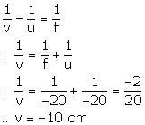
Hence, the image is 10 cm in front of the lens on the same side as the object.
(ii) For a lens, magnification is
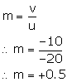

Question 9
A convex lens forms an inverted image of size same as that of the object which is placed at a distance 60 cm in front of the lens. Find:
(a) The position of image, and
(b) The focal length of the lens

Answer 9
A convex lens forms an inverted, real and an image of the same size as the object when the object is placed at 2f, i.e. (u=2f).
(a) In such cases, the image is formed at the point which is double the focal length on the other side of the lens (2f₂).
(b) To find the focal length of this lens, we use the relationship:
object distance (u) = 2f
object distance = 60 cm …(given)
60 = 2f
f = 30 cm
So, the focal length of this lens is 30 cm.

Question 10
A concave lens forms an erect image of 1/3rd size of the object which is placed at a distance 30 cm in front of the lens. Find:
(a) The position of image, and
(b) The focal length of the lens.

Answer 10
(a)
Given that the concave lens forms an erect image of 1/3rd size of the object.
That implies that the magnification provided by the lens is 1/3.
Magnification is given by
The position of the image formed is 10 cm on the same side of the lens where the object is placed.
(b)
Focal length of a lens is given by
The focal length of the given lens is 15 cm.

Question 11
The power of a lens is +2.0 D. Find its focal length and state what kind of lens it is?

Answer 11
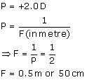

Question 12
Express the power(with sign) of a concave lens of focal length 20 cm.

Answer 12

Question 13
The focal length of a convex lens is 25 cm. Express its power with sign.

Answer 13
Focal length, f = +25 cm = +0.25 m
Power of a lens is
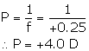

Question 14
The power of a lens is -2.0 D. Find its focal length and its kind.

Answer 14
We know that power of a lens is given by the formula
As the power of the given lens is negative, i.e. -2.0 D, it is a concave lens.

Question 15
The magnification by a lens is -3. Name the lens and state how are u and v related?

Answer 15
The negative value of magnification suggests that image is real and inverted. The magnitude of magnification is greater than 1 which means image is enlarged. Therefore the lens should be convex lens.
Relation between u and v is given by
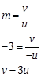
This shows that image distance is 3 times that of object distance.

Question 16
The magnification by a lens is +0.5. Name the lens and state how are u and v related?

Answer 16
The image formed by the concave lens is always virtual, erect and smaller than the object. Therefore the magnification is always positive and less than 1.
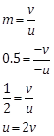
This shows that object distance is twice of image distance.

Question 17
A concave lens is a focal length 30 cm. Find the position and magnification (m) of image for an object placed in front of it at distance 30 cm. State whether the image is real on virtual?

Answer 17
Object distance=-30cm
Focal length=f=-3-cm
Image distance=v=?
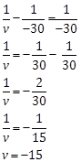
Here image formed is virtual and erect.

Question 18
Find the position and magnification of the image of an object placed at distance of 8.0 cm in front of a convex lens of focal length 10.0 cm. Is the image erect or inverted?

Answer 18
Object distance=u=-8cm
Focal length f=10cm
Image distance v=?
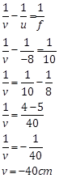
As the object is placed between the focus and optical center of the lens the image formed is virtual and erect.

Selina Physics Solution Refraction Through Lens

Exercise 5(D)

Question 1
What is magnifying glass? State its two uses.

Answer 1
Magnifying glass is a convex lens of short focal length.That is mounted in a lens holder for practical use.
Lens is used to see and read the small letters and figures and It is used by watch makers to see the small parts and screws of the watch.

Question 2
Draw a neat labelled ray diagram to locate the image formed by a magnifying glass. State three characteristics of the image.

Answer 2
Let the object (AB) is situated between focal length and optical centre of a convex lens then its image (A’B’) will form on the same side of lens.
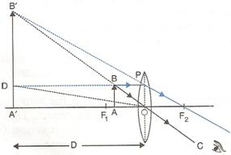
The image formed will be virtual, magnified and erect.

Question 3
Where is the object placed in reference to the principal focus of a magnifying glass, so as to see its enlarged image? Where is the image obtained?

Answer 3
The object is placed between the lens and principal focus.
The image is obtained between the lens and principal focus.
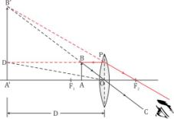

Question 4
Write expression for the magnifying power of a simple microscope. How can it be increased?

Answer 4
The magnifying power of the microscope is defined as the ratio of the angle subtended by the image at the eye to the angle subtended by the object (assumed to be placed at the least distance of distinct vision D = 25 cm) at the eye, i.e.,
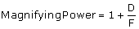
where F is the focal length of the lens.
The magnifying power of a microscope can be increased by using the lens of short focal length. But it cannot be increased indefinitely.

Question 5
State two applications each of a convex lens and concave lens.

Answer 5
The two applications of a convex lens are:-
(i)It is used as an objective lens in a telescope, camera, slide projector, etc.
(ii)With its short focal length it is also used as a magnifying glass.
The two applications of a concave lens are:-
(i)A person suffering from short sightedness or myopia wears spectacles having concave lens.
(ii)A concave lens is used as eye lens in a Galilean telescope to obtain an erect final image of the object.

Question 6
Describe in brief how would you determine the approximate focal length of a convex lens.

Answer 6
The approximate focal length of a convex lens can be determined by using the principle that a beam of parallel rays incident from a distant object is converged in the focal plane of the lens.
In an open space, against a white wall, a metre scale is placed horizontally with its 0 cm end touching the wall.
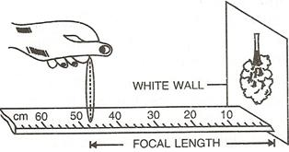
By moving the convex lens to and fro along the scale, focus a distant object on wall. The image which forms on the wall is very near to the focus of the lens and the distance of the lens from the image is read directly by the metre scale. This gives the approximate focal length of the lens.

Question 7
The diagram in Fig. shows the experimental set up for the determination of focal length of a lens using a plane mirror.
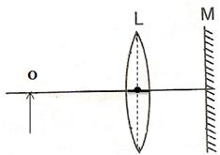

(i)Draw two rays from the point O of the object pin to show the formation of image I at O itself.
(ii)What is the size of the image I?
(iii)State two more characteristics of the image I.
(iv)Name the distance of the object O from the optical centre of the lens.
(v)To what point will the rays return if the mirror is moved away from the lens by a distance equal to the focal length of the lens?

Answer 7
(i)
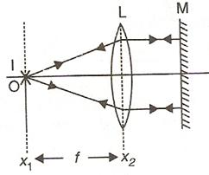
(ii)The size of the image will be same as that of object.
(iii)The image formed will be real and inverted.
(iv)The distance of object O from optical lens will be equal to the focal length of the lens.
(v)The position of the mirror from lens does not affect the formation of image as long as the rays from the lens fall normally on the plane mirror M.

Question 8
Describe how you would determine the focal length of a converging lens, using plane mirror and one pin. Draw a ray diagram to illustrate your answer.

Answer 8
To determine focal length by using plane mirror we need a vertical stand, a plane mirror, a lens and a pin.
Place the lens L on a plane mirror MM’ horizontally. Arrange a pin P on the clamp of a vertical stand such that the tip of pin is vertically above the centre O of the lens.
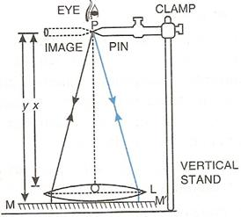
Adjust the height of the pin until it has no parallax (i.e., when the pin and its image shift together) with its inverted image as seen from vertically above the pin.
Now measure the distance x of the pin from the lens and the distance y of the pin from the mirror, using a metre scale and a plumb line. Calculate the average of the two distances. This gives the focal length of the lens, i.e.,
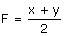

Question 9
How will you differentiate between a convex and a concave lens by looking at (i) a distant object and (ii) a printed page?

Answer 9
(i) On seeing a distant object through the lens, if its inverted image is seen, then the lens is convex, and if the upright image is seen, then the lens is concave.
(ii) On keeping the lens near a printed page, if the letters appear magnified, then the lens is convex, and if the letters appear diminished, then the lens is concave.

Refraction Through A Lens

Multiple Choice Type – 5(D)

Question 1
A magnifying glass forms:
(a) A real and diminished image
(b) A real and magnified image
(c) A virtual and magnified image
(d) A virtual and diminished image

Answer 1
A virtual and magnified image
Hint: A magnifying glass forms a virtual, magnified and upright image on the same side as the object.

Question 2
The maximum magnifying power of a convex lens of focal length 5 cm can be:
(a) 25
(b) 10
(c) 1
(d) 6

Answer 2
Focal length of convex lens, f = +5 cm
Magnifying power of convex lens (simple microscope) is
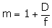
D is the distance of distinct vision, D = 25 cm
